**C programming**

**Kernighan and Ritchie 2nd edition**

Notes: First video series is referred to and then revised using K&R

Author: Harsh Dubey

**Chapter 1: Variables**

**Content:**

1. Variable names
2. Data type and sizes: Overview
3. Integer
4. Character
5. Float, double and long double
6. Scope of variable
7. Auto modifier
8. Extern modifier
9. Header file
10. Register modifier.
11. Static modifier
12. Volatile modifier
13. Const and #define.
14. Scanf and printf

**Variable names:**

**Variable:** Variable in C is something who’s value can change during runtime/execution.

**Declaration:** Rules for declaring the variables.

1. **First** character must be a **letter.**
2. **Underscore** counts as a letter.
3. **Upper and lower** are different names. X and x are different names.

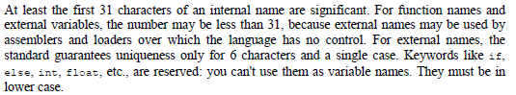

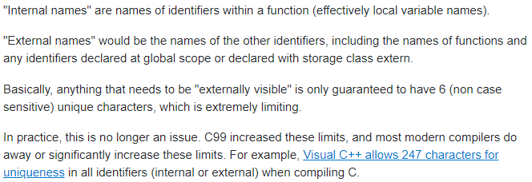

**Data type, size qualifier and sign qualifier:**

1. **Four** kinds of data types: **Char, int, float, double**

* **Char:** character whose size is **1 byte**.
* **Integer:** + or – whole numbers. Size is **4 bytes**.
* **Float:** Single precision floating point numbers or fractions (**7-digit precision**). Size is **4 bytes**.
* **Double:** Double precision floating point numbers (**16-digit precision**). Size is **8 bytes**.

1. **Qualifiers based on size:** Change size of data types.

* **Short and long** apply to **integers**. Typically, Int is 4 bytes, short int is 2 bytes and long int is 8 bytes. You can **omit Int** keyword, and the default is **int.**
* **Long** can also be used **for double**.

1. **Qualifiers based on sign:**

* **Signed and unsigned** can be applied to any characters or integers. Will change the range of the data type.

1. **<limits.h> and <float.h>** contain symbolic constant.

**Question: 2.1:**

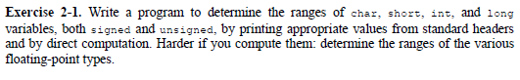

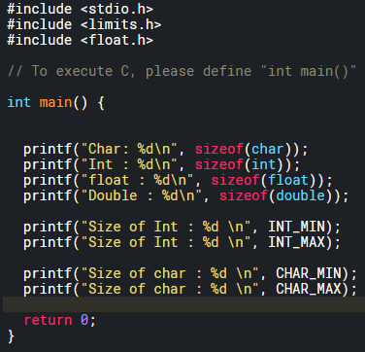

**Integer:**

1. Store’s integers (+ and -)
2. **Default is signed – “int x”**
3. Find size using” **sizeof** ” operator.

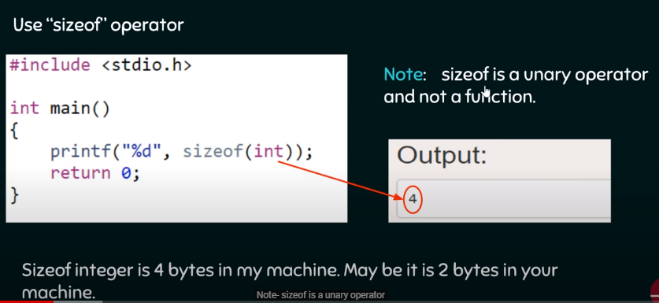

1. Find **range using <limits.h> .**

* **Unsigned** range is **0 to (2^n -1).**

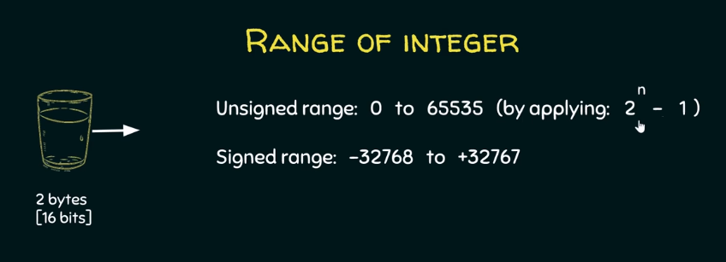

* **Signed** range is **(-2^(n -1)) to (2^(n -1)-1).**

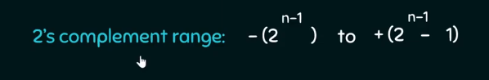

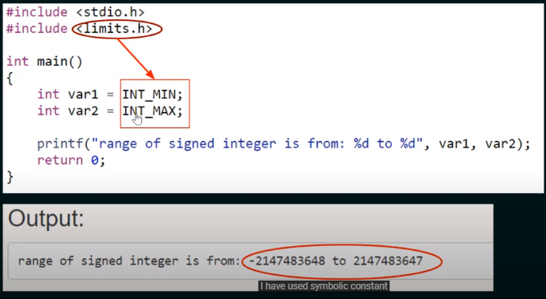

1. Print using **%d** for **signed** and for **unsigned** print using **%u.**
2. If printed using %d then only signed representation can be printed doesn’t matter if you’ve assigned it as unsigned or not.

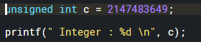

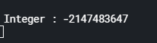

1. **Overflow:** Circle of integer repeats when values go beyond the range.

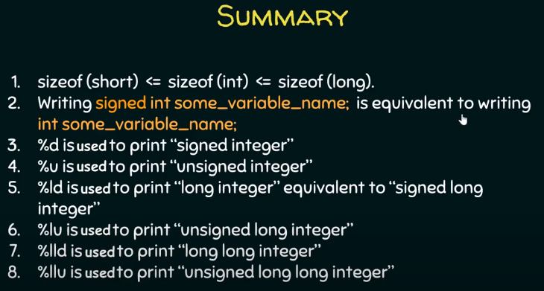

**Character:**

**Character:** Every character has a binary representation in machine.

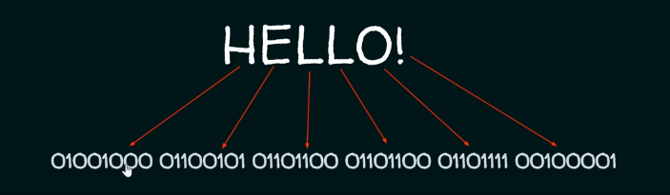

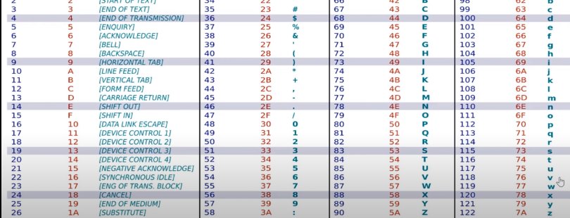

1. Character are ASCII encoded; everything must have a number. Hence, even **nonprintable character has to be encoded**, remember printing space on screen is what you used to clear the LCD in PIC 18. ASCII uses 7 bits.
2. Difference between **unsigned char and signed char**

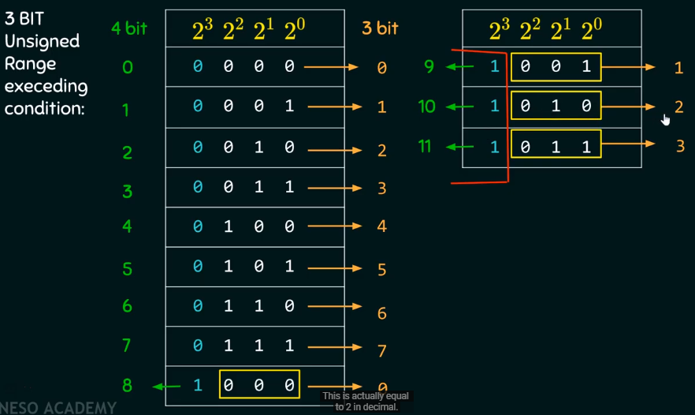

**Float, Double and long double:**

1. **Float: 4 bytes**; use %f to print it; by default %f and lf will print 7 digits. **%.16f** will print it upto 16 decimal places; however, float can only print upto 7 digits starting from before the decimal point.

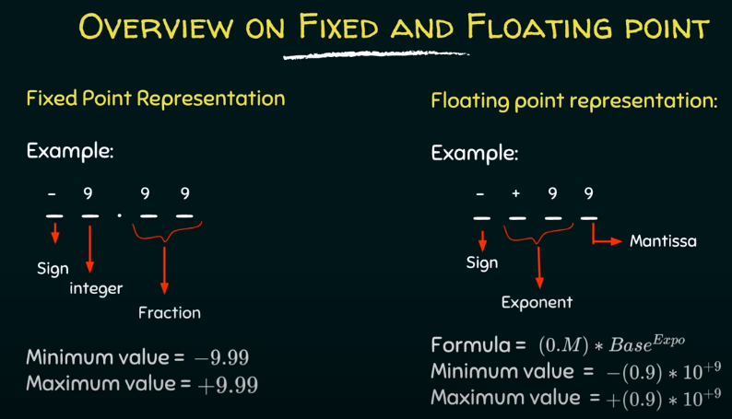

1. **Double: 8 bytes**; use **%lf** to print; double can print upto **16 so higher precision**
2. **Long double 12 bytes**; use **%Lf** to print; capital L; long double can pint **upto 19.**
3. **Why use Double instead of float: Size and precesion**
4. **To round up or round down use. f, nothing printed after the decimal.**

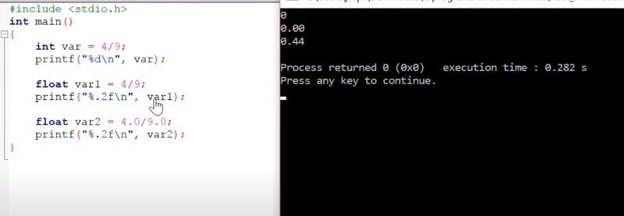

1. For **int,** 0 is printed there, since int will **truncate whatever is after the decimal point.**
2. For float is print 0.00 since **4 and 9** are an **integer value**
3. Therefore, just put **.0 at the end**, by default it is double. To make it float just put float at the end.

**Type casting a variable:**

1. **What is type casting:** Type casting is better explained with an example.
2. **Let’s analyze the behavior of data types in C:**
3. Case 1: Printing a double/float using a %d operator: %d will truncate anything beyond the decimal.
4. Case 2: printing a interger using %lf: 0.0000.

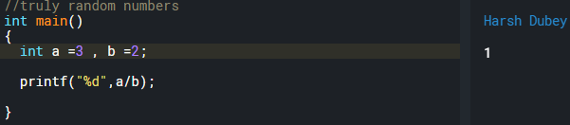

1. **Type casting:** C thinks if **int/int** or **int*int** will be a integer. That’s why type casting.
2. **Type casting operator:** Type casts **single operand** to the right.

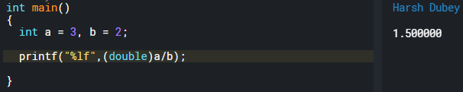

1. **Rules for type casting:** Smaller into bigger or same size into same size. Can type cast bigger in smaller. But then loss of data occurs.
2. **Use of typecasting and an example:**

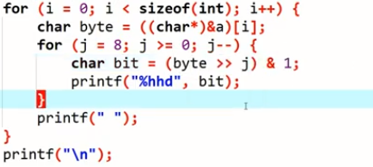

**Scope of Variable:**

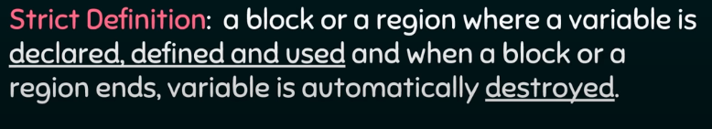

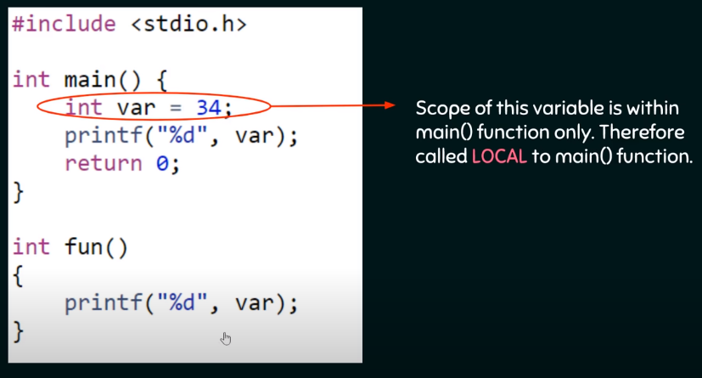

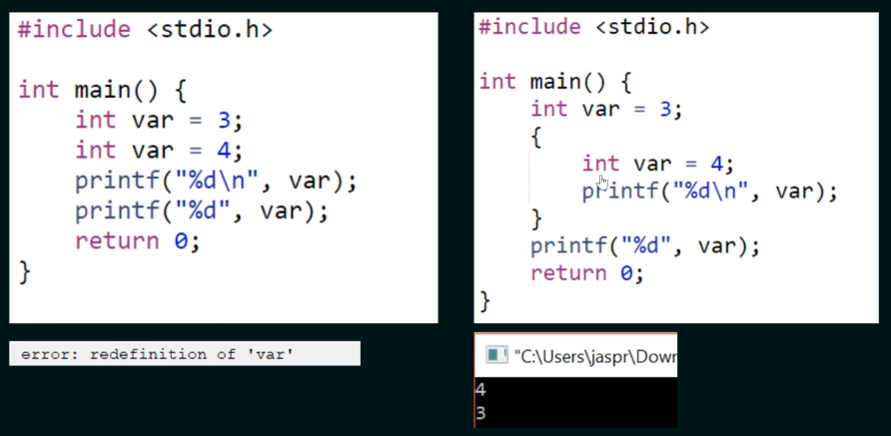

1. Block of code is not just separate functions but also can be created by using **curly brackets**.
2. **Global Variable:** Is also called external variable.

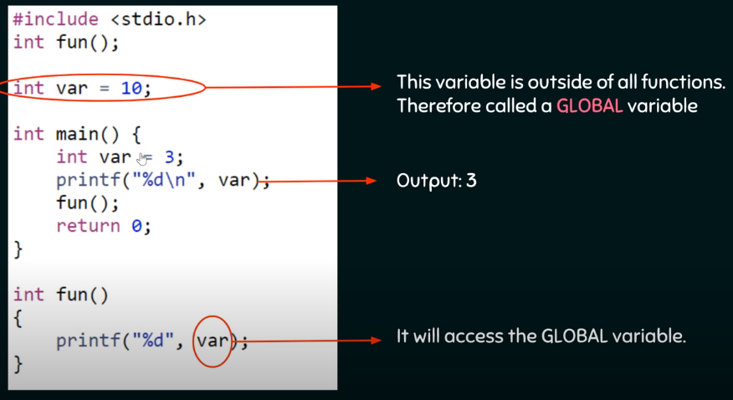

**Modifier:**

**Auto Modifier:** Automatically **destroyed.**

1. Every variable is a auto variable by default.

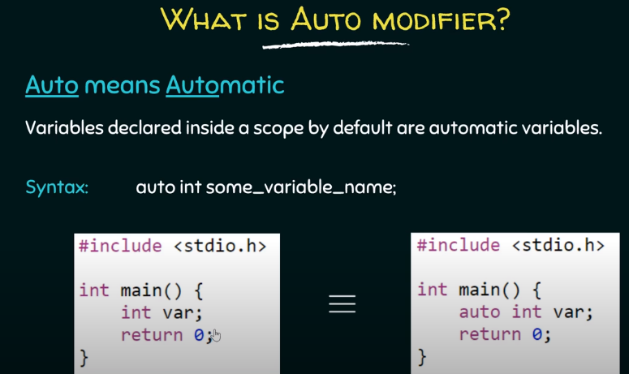

1. Declare an auto variable or a **normal variable and print it**, It will print a **garbage value**
2. Declare a **global variable** and try to print it. It will print **0.**

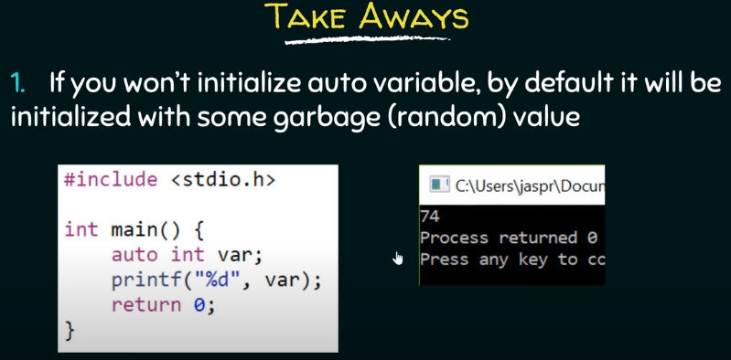 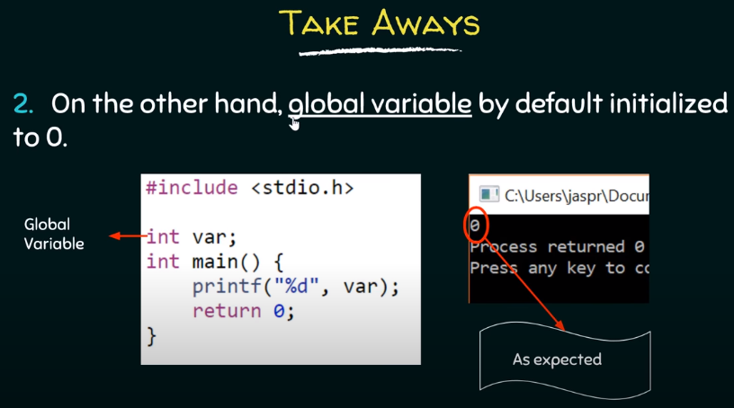

**Extern Modifier:**

Scoping rules:

1. **Why** need **scoping rules**? Bc the whole program of C **need not to be compiled at the same time**. We can have **different files** that are compiled at different times. And previously compiled routines may be loaded from other **libraries.**
2. Scope of **automatic variable**:

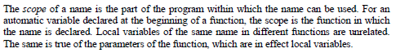

1. Scope of **extern variable and functions**:

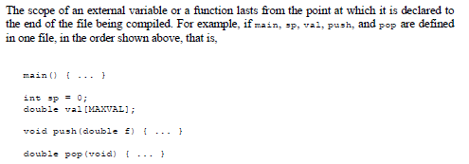

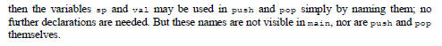

1. **Extern variable** in same file and **out of scope** declaration. Variable referred to before it is defined.

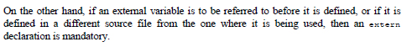

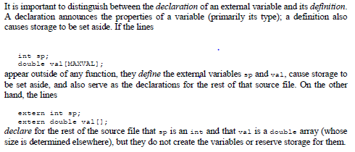

1. In **extern keyword** below, the extern declares the variable but doesn’t define it. Hence no memory space is reserved, hence no value is stored and hence no value is printed.

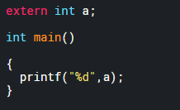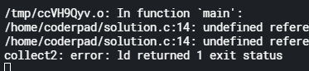

1. Let us define it out of scope now.

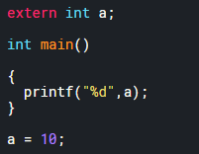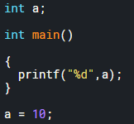

Output is 10 in both cases.

1. Let us define a global variable with extern.

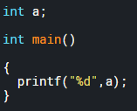

Output is 0 in this case. Since, it is a global variable.

1. Only one definition is allowed of extern variable.



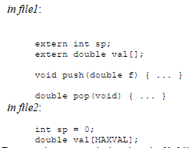

1. **Declaration means variable exists**, and **definition means book a memory space for** it.
2. Extern modifier: The variable is externally declared (out of scope) and defined in some other file. Therefore, don’t define it.
3. Who can modify the variable? - **Linker links all the files together**. Compiler compiles the file.

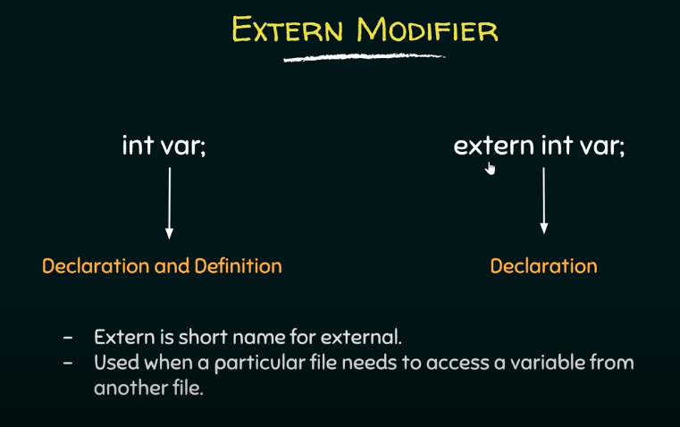

1. Extern just says to the block that the variable is defined out of scope. **Used when a particular file needs to access a variable from another file.**

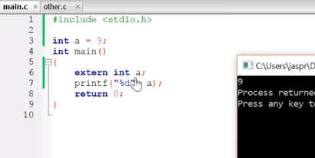

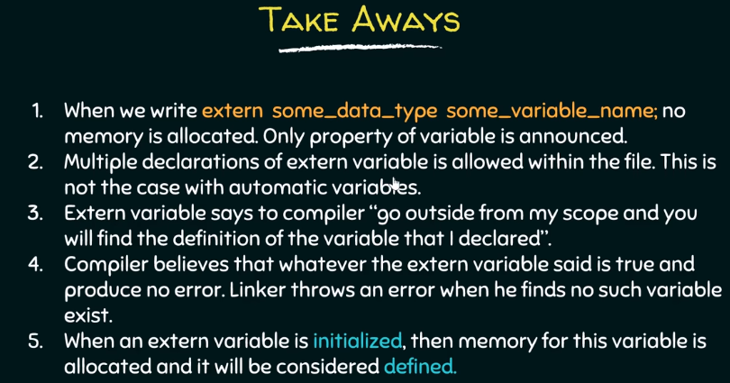

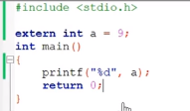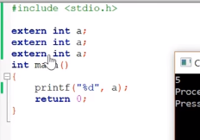

1. Multiple **declarations are allowed** but **multiple definitions are not allowed**.
2. Once the **extern variable is initialized** then memory for it is allocated and will be **considered defined.**

**Header file:**

Keep things centralized. Below picture explains it very nicely.

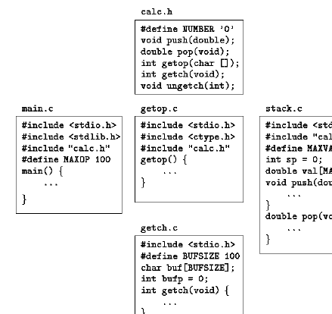

**Register Modifier:**

* 
* 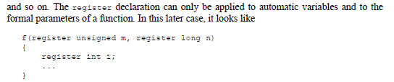

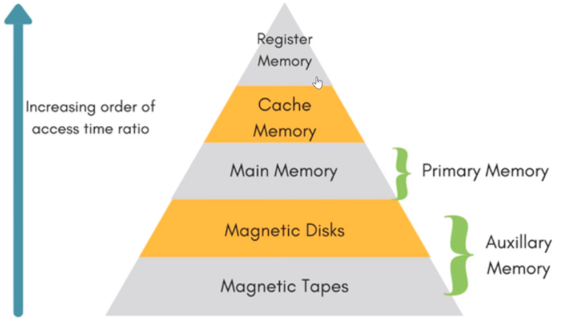

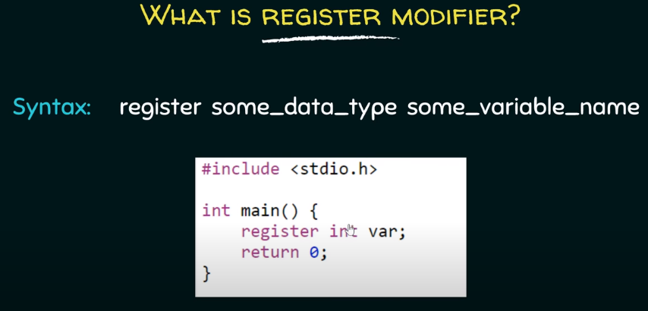

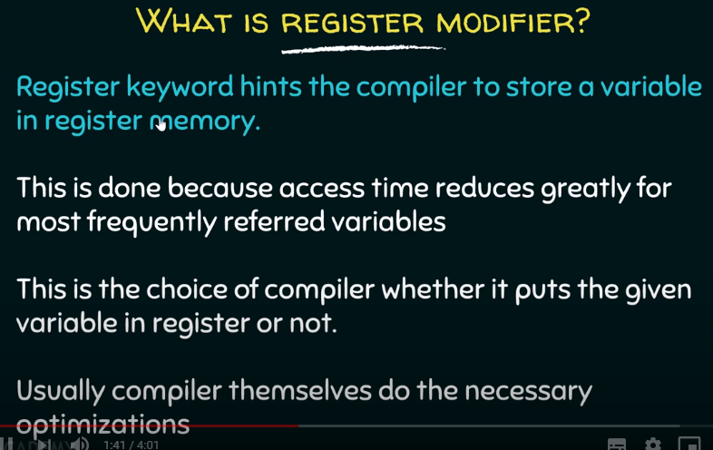

1. Whichever **variable needs to be accessed multiple times,** put that in register file. Since **access time is fastest** in it.

**Static modifier:**

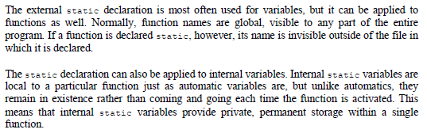

1. How to protect a global variable from other files? – Declare it static

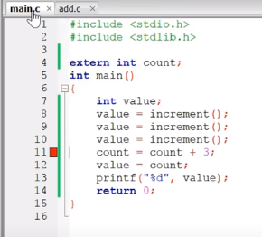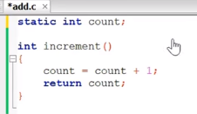

1. How to protect It from other functions within the same file? Declare it within the same function as static.
2. Static also makes the variable “STATIC” which means once it’s initialized with certain value within a function, then it won’t be reinitialized again if the function is called again.
3. By default, it’s initialized to 0, Just like global variable even though it’s declared locally.
4. And can’t be initialized using a variable.

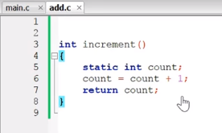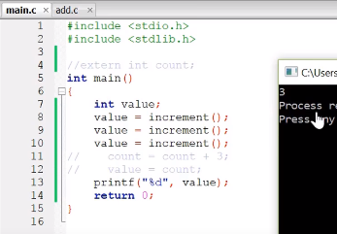

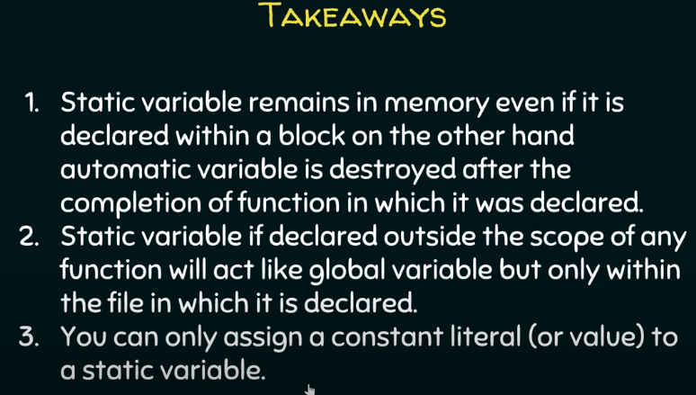

**Volatile modifier:**

1. **Why volatile:** Everything is fine until the bloody compiler optimizes the variable.

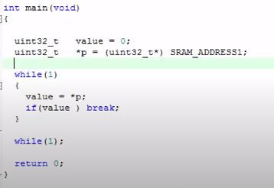

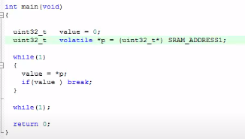

1. **Drawback of volatile keyword:** It can affect the variable if it is in the loop.

**Semaphore:**

**Why semaphore: To protect** from **volatile** keyword.

**What is semaphore:** Integer value/ flag/semaphore variable used to protect the running code.

1. **Counting semaphore:** P wait and V signal.

Semaphore = -3

P4, P5, P6

Entry Code

Critical section

P1, P2, P3

Exit Code

1. **Entry code:** P – wait – down.

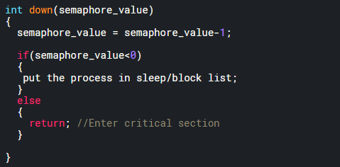

1. **Exit code:** V – signal – up.

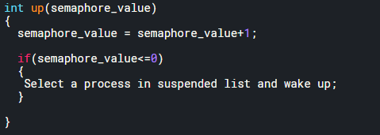

1. **Binary semaphore:** P wait and V signal.

Semaphore = 0/1

P2

Entry Code

Critical section

P1

Exit Code

1. **Entry code:** P – wait – down.

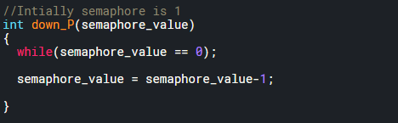

1. **Exit code:** V – signal – up.

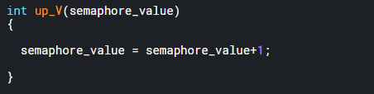

**Processes and Multi-processes programming in C:**

**What is Process: Main process** is a process. Can create child process using **fork ()** function.

1. **Header file: #include <unistd.h>**
2. **Fork:** Create a new timeline from the **line of fork instantiation**. Two **fork () will create 2 to power 2 processes timeline.**
3. **Fork** returns a **integer ID**. **Baby timeline** has a **id** of **0. Father timeline** has a **non-zero ID**.

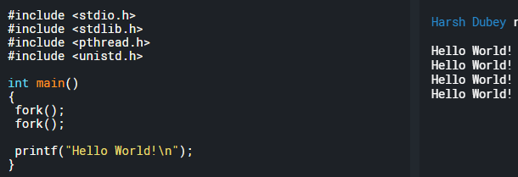

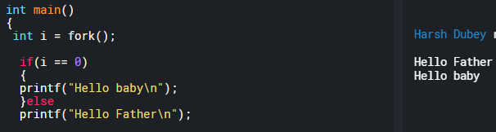

1. **How to create 3 processes?**

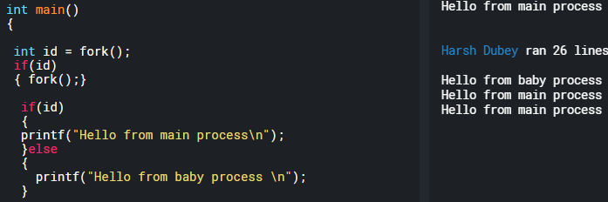

1. Create a **fork process** and print first **5 number of 1-10** using **baby process** and then **next five using main process: fflush(stdout);** and **wait();**
2. Main process is executed first here, but the idea is that **both main process** and **child process** are **happening at the same time.** **fflush(stdout)** will **print** the **characters as they are written in the LCD buffer. O**therwise it will wait for it to fill the buffer and then print every thing.

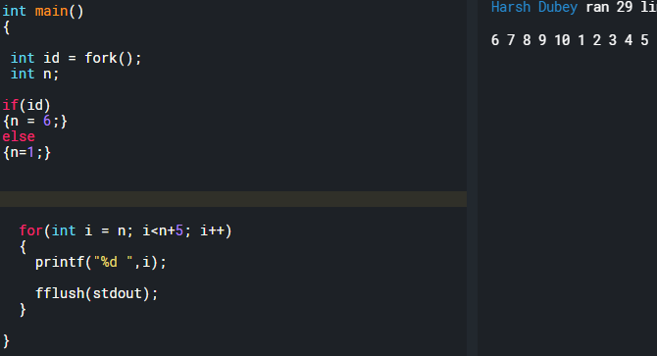

1. To make the main process wait. Use **wait()** function.

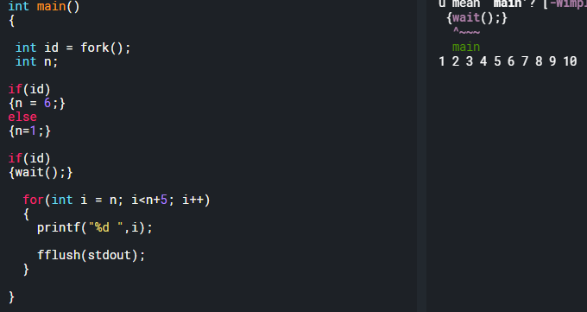

1. **How are process id’s assign?** 2^fork(): 00,01,10,11
2. Child of child = **0,0**
3. Main: **1,1**
4. Whatever **Id the child is born of will be Zero**.
5. **Rest whatever is left the child will inherit**.
6. **Pipe** the process: Transfer **data between the processes.**

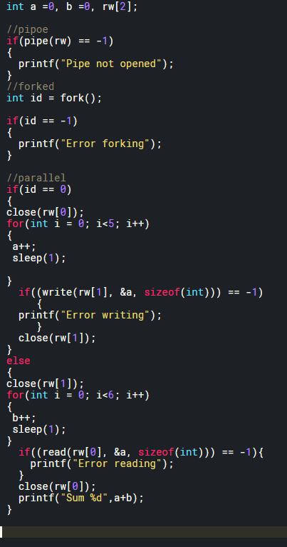

1. Ex: Find sum of array by exploiting multiple processors on your system
2. In the below example: Not **everything is faster** with **parallel processing.**

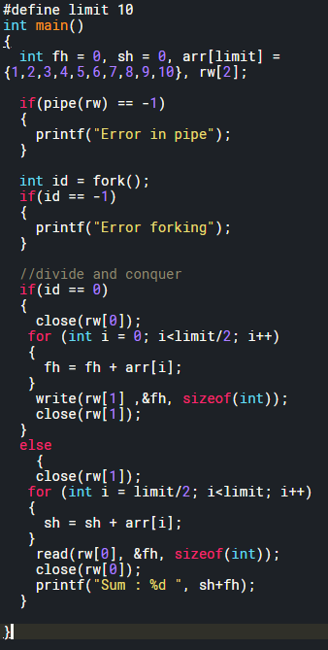

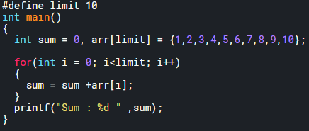

1. **Piping with more than two processes:**

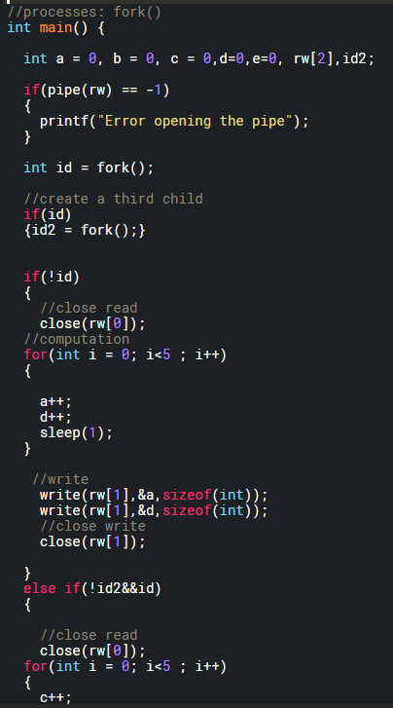

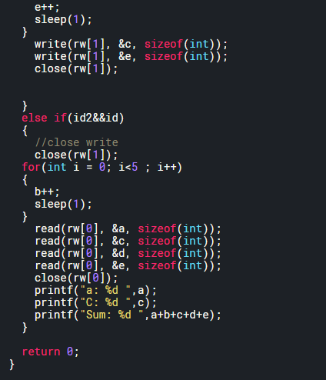

**Threading in C:**

**What is threading:**

1. **Pthread_t : API** will store information about the thread.
2. **Pthread_create: Create Thread:** look at the image for more understanding.
3. **Pthread_join: Wait ();** from process. Will wait for the function to execute and send the **return value.**

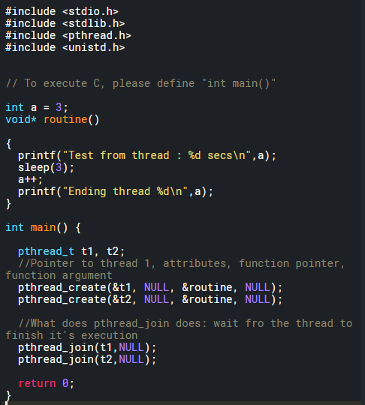

1. **Difference between Threads and Processes:**
2. Processes: Different ids, Threads: Same Id.
3. **Single process can** have **multiple threads**, but **single thread** **can’t** have **multiple processes**.
4. Processes: **Copied resources.** Threads: **Shared Resources.**
5. **Race conditions:** Below is called the race condition.
6. Figure 2
7. Creation of threads. If less conditions are there, then by the time the 2nd thread is create the first thread is already done with its work.

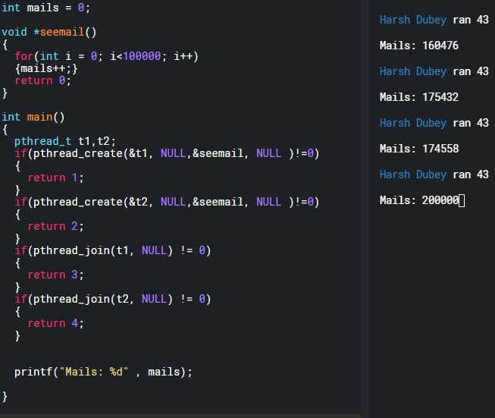

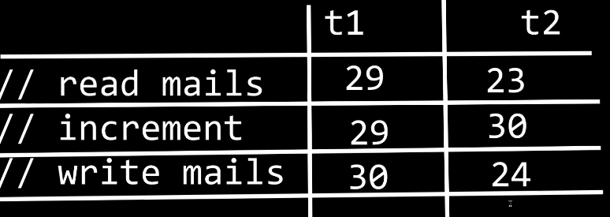

1. **Mutex:** Way to **solve** a **race** **condition:**
2. **Declare: pthread_mutex_t**
3. **Define: pthread_mutex_init();**
4. **Destroy: pthread_mutex_destroy();**

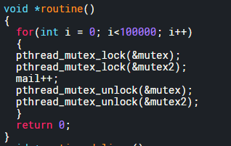

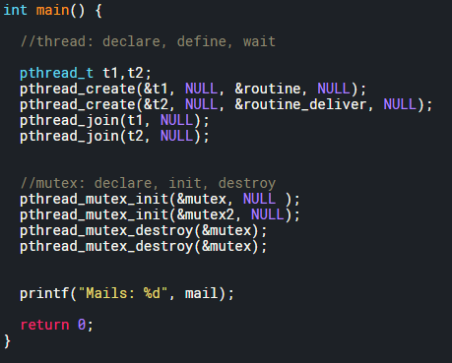

1. **Creating multiple threads using for loop:**

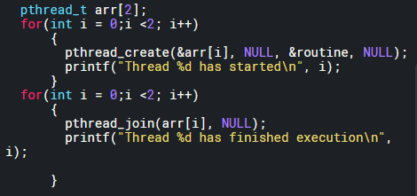

1. **Get a return value from thread:** pthread_join (Study pointer and memory allocation for that)
2. **Pass arguments to thread: to 18**

**19. Deadlock: Nothing** will **execute.**

1. **Single deadlock:** Lock the same mutex twice.
2. **Swap deadlock: rand()%2** could lead to dead lock.
3. **Two thread deadlock:** Two threads executing different functions and locking two different deadlocks in inappropriate order.

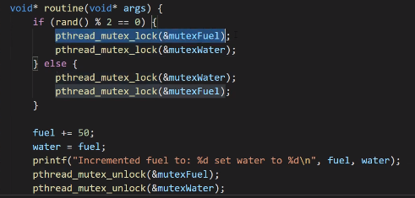

**20. Recursive Mutex:** A mutex that can be **locked multiple times** is called a **recursive mutex**.

1. **Why recursive mutex?** Recursive functions need recursive mutex, since the function calls itself.

**21. Semaphore: Binary and counting semaphore:** Semaphores are basically used to create ques. Binary semaphore acts like mutex but doesn’t give ownership to one thread.

1. **How to create a semaphore:** Declare, init, destroy







1. **How to use:** sem_wait(&semaphore) : sem_post(&semaphore)

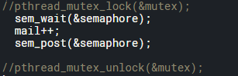

1. **How to change it to counting or binary?** In init use to 3rd argument as n value for semaphore.



1. **How to add multiple process?** In init use to 2nd argument as number of processes.

**22. Semaphore vs Mutex:** Semaphores doesn’t give ownership to any one thread, mutex gives complete ownership. Basically, another thread in the program could unlock the mutex locked by a different thread.

23. **Practical example of semaphore:** Game server example

24.

**Random number generation: <stdlib>**

1. **Random number generation:** using rand() and srand().
2. **Rand() :** Will give you pseudo random number. If the code is executed multiple times than we will get the same set of random numbers.
3. **Srand(x):** We can seed rand() with a **unsigned integer** and get a new pattern. But again, the new pattern will repeat if program executes multiple times. Rand() by default runs with **seed of 1.**
4. Seed **Srand(x)** takes 32 bit value with **time (NULL). #include<time.h> %6 will give numbers from 0 to 5.**
5. **Time() takes in a pointer and returns the 64 bit time value and store it in that location of the pointer.**

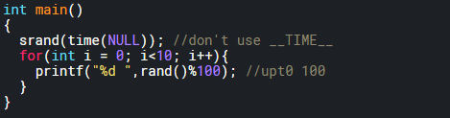

1. **Print random number in positive range:**

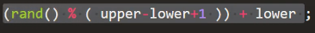

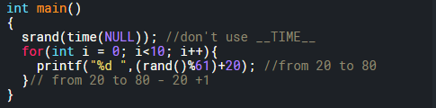

1. **Print random numbers in negative to positive:**



1. **Floating point random number:** To generate a random floating point we need to do math. **Rand() will return an integer** hence type cast it and divide it by another integer to get random floating point value.

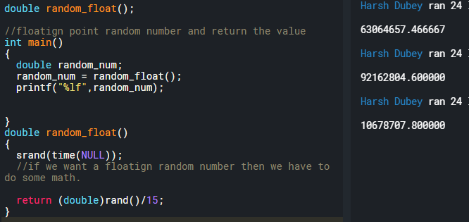

1. **Floating point numbers from 0 to x:**

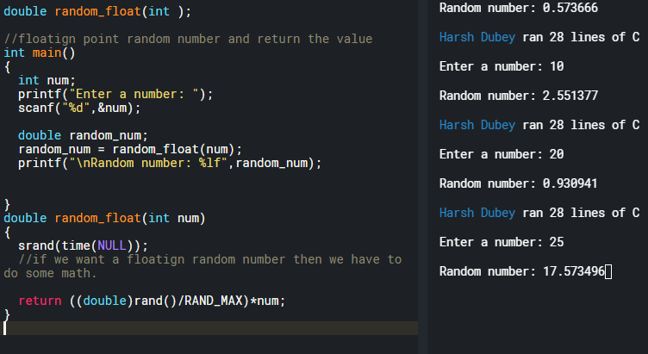

1. **Floating point random number in a range:** Just add the upper value to the return. If num is 5 then the range will be from 5.5 to 5.5+num.



**Constant: #define and const:**

**Macro:** Defining constant using #define.

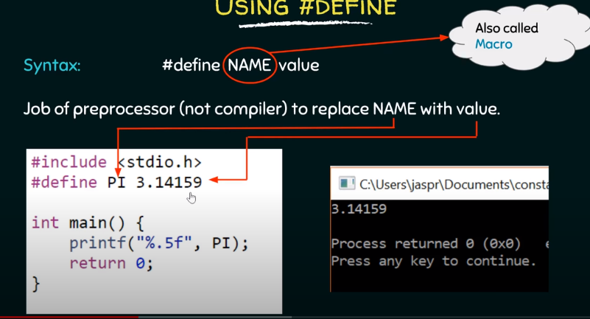

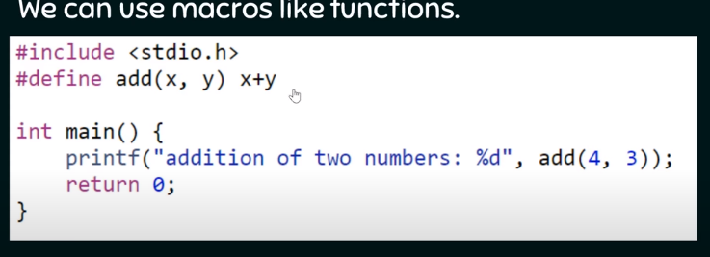

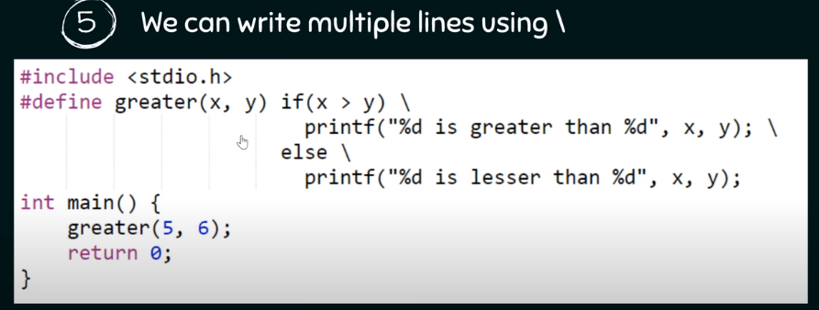

1. You can use macros to print and compute. But code blocks don’t let ya just compute.
2. Below is not allowed.
3. 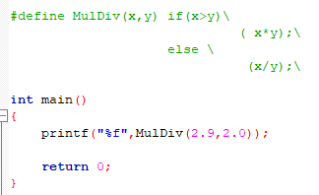
4. Below is allowed.

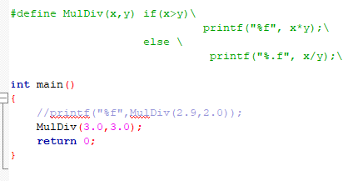

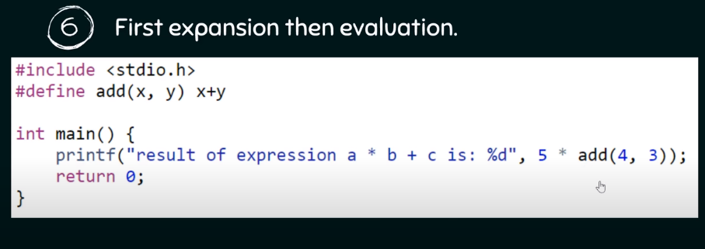

1. It will print 5*4+3 = 23, not 35

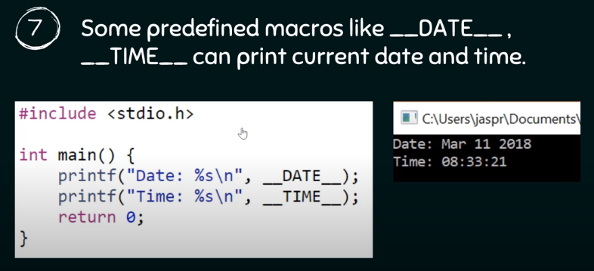

1. Macros to print date and time.

**Defining constant using Const:**

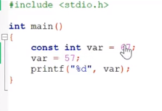

1. Can’t change the value later in the code.

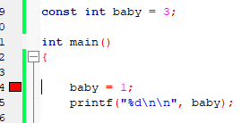

1. But can be reinitialized.

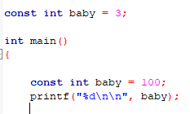

1. But can’t be reinitialized in the same scope.

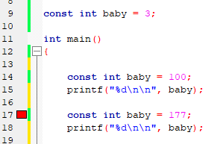

**Questions:**

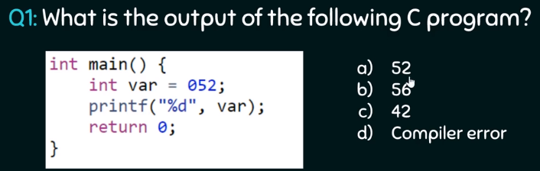

**Answer:** When we put zero in front of any value then we are making it a octal value.

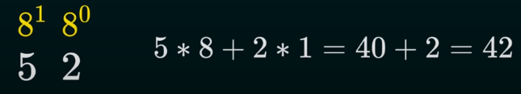

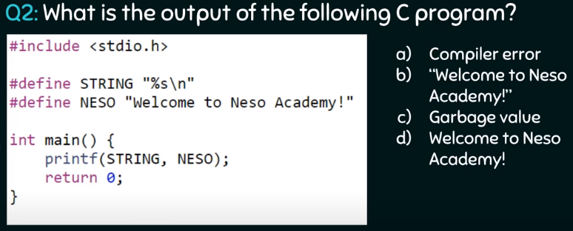

Answer: D, no double quotes

**Scanf and Printf and File terminal I/O operations:**

1. **Scanf and how to read a line of text in C?**
2. **Using scanf with “%s” :** Will terminate after a “Space”. Will not take what’s written after the space.

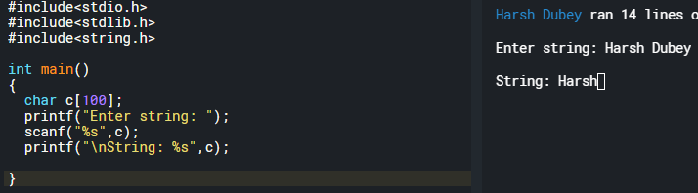

1. **Use scanf with [^\n] operator to accept the space:** This will tell the scanf that take everything before the \n.

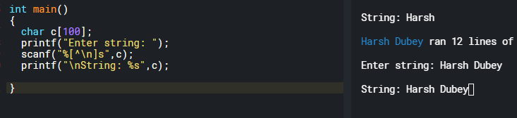

1. **But problem comes when two string are supposed to be taken from the user:** Since the old \n from the display buffer is not taken out. The [^\n] reads the \n from last string and the terminates.

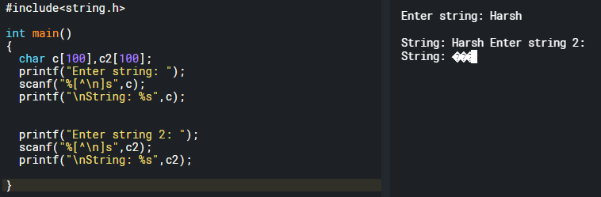

1. **How to fix this:** remove the \n from the buffer by using **getchar()** function to remove \n. However, bounds of the array are still insecure.

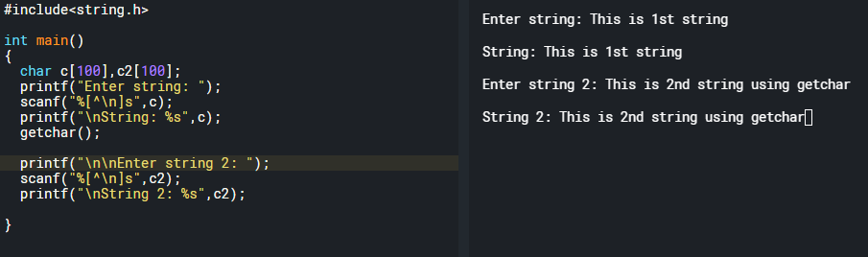

1. **We can secure the size of array by using scanf:** If we type extra characters then it won’t store in the string, but it will store that in the display buffer.

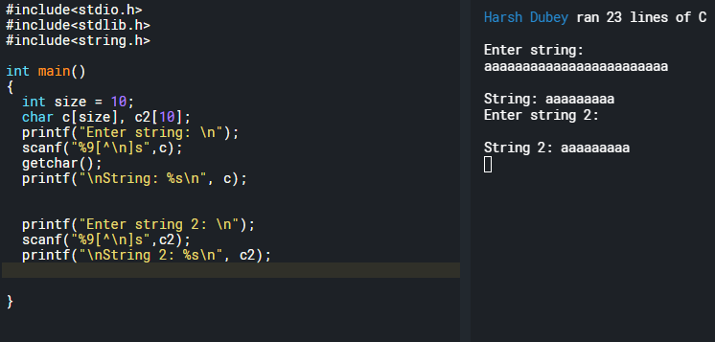

1. **However we can use something better to secure the bounds:** fgets(array, number of characters, stdin);
2. **Caveat:** It takes enter as an extra character. Notice the string length.

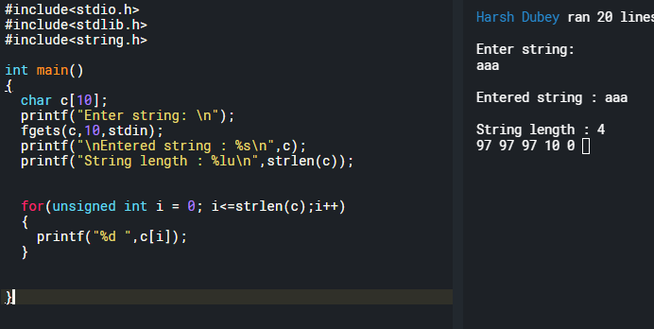

1. **Fix this by putting 0 at strlen – 1:** But now the string will only accept 8 characters.

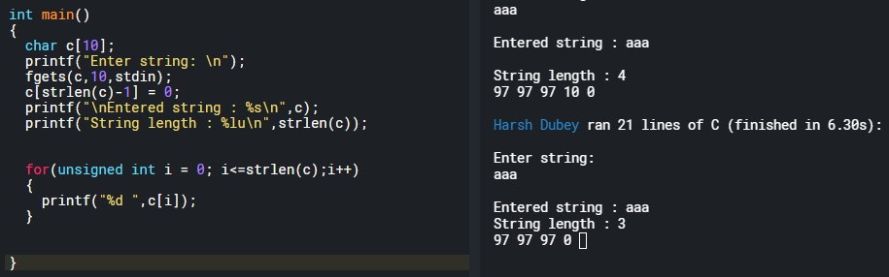

1. **Working with scanf and fgets():** scanf() leaves \n and “enter” that needs to be cleared if scanf and fgets have to be used together. Use fgetc() to remove the **enter.**

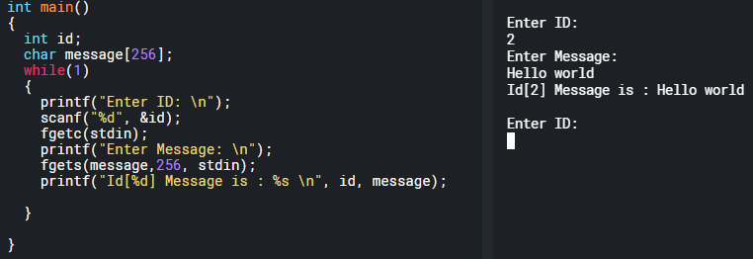

1. **Printf:**
2. Align the printed numbers to the right? By default, everything is aligned to left. **Pad it by some constant number.**

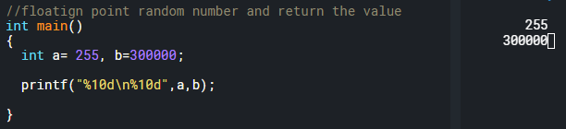

1. **Print Hex:** Hex : %x: small hex and %X: capital hex and %#x: 0xhex

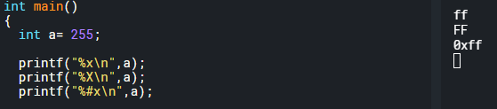

1. **Print address of the variable:**

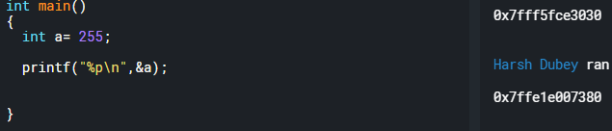

1. **Print oct:** use %o.
2. **Reverse a string using fgets and scanf:**
3. **Fgets:**

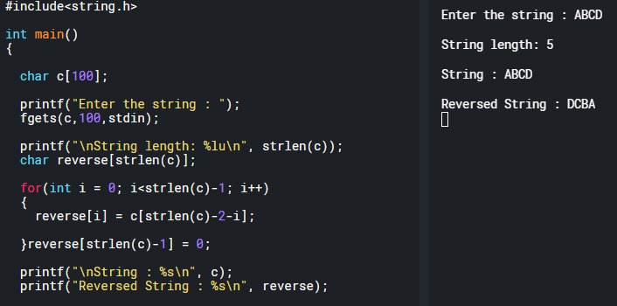

1. **Scanf:**

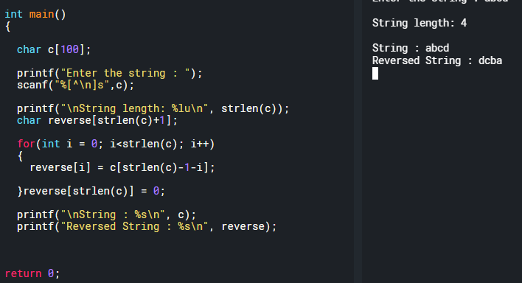

1. **Getc, getch, getche, getchar :**
2. **Getc and getche:** are basically obsolete.
3. **Getc(stdin)/fgetc(stdin):** basically, just gets a character form the screen and returns it.
4. **Getchar():** is basically getc(stdin)
5. **Putc, putch, putchar():**
6. **Putchar():** Takes and integer and then converts that to a character and prints it. Also, takes in character and prints it.

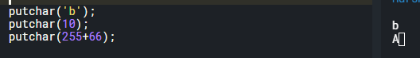

1. **Putc(): putc(‘e’,stdout);** takes two parameters, one is the character and other is the stream to write to. Stream, i.e., input /output.
2. **Return value of putchar and putc:** is the character they print on the screen.
3. **Putc(‘e’,stdin):** Will return an EOF.
4. **Ungetc(c,stdin):** To read what’s in then output buffer and then put it back in input buffer.

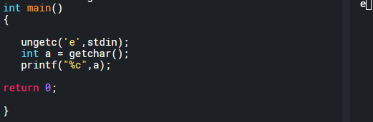

1. **Gets() vs fgets():**
2. **Vulnerability of gets() and a good example to understand memory layout and type casting:**

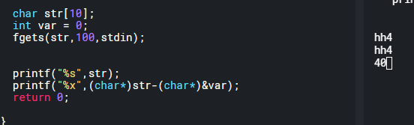

1. **Printf: 32 different functions**
2. **S – buffer:** Example: sprint: write formatted string to a buffer.

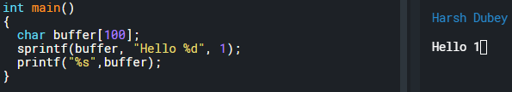

1. **N- buffer size:**

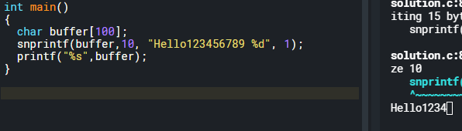

1. **F – file or stderr:** you can open a file and write to it then and there i.e. fprintf.



1. **_s : safer version of fprintf:** Used for safer file operations.

**Questions**

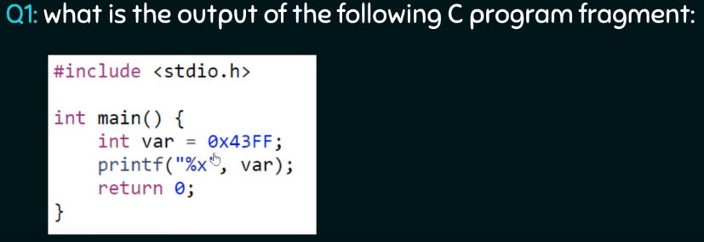

Answer: %x is used to print out hex

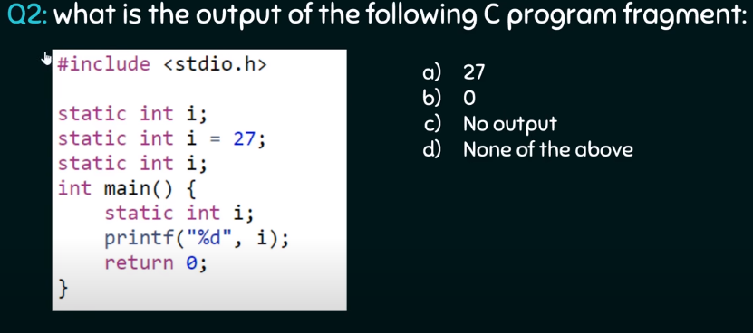

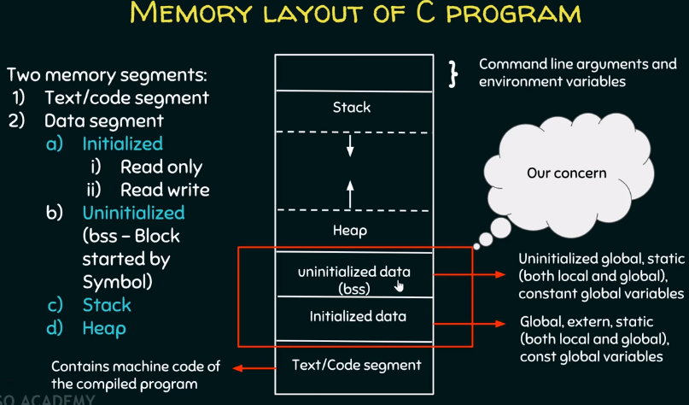

**Operator in C:**

**Arithmetic Operators:**

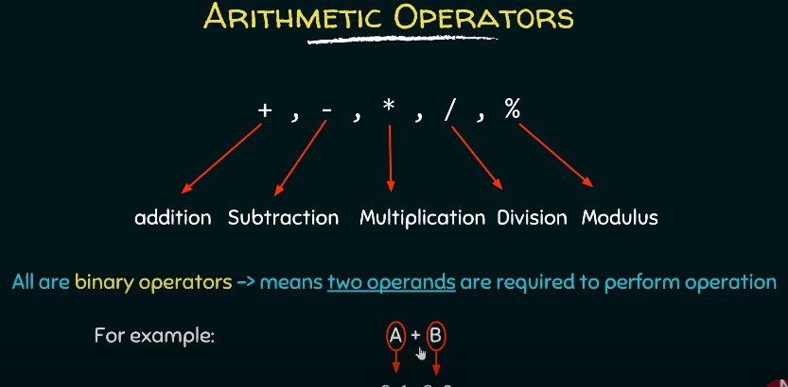

1. Modulus = remainder

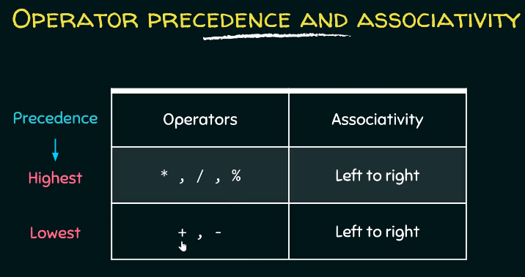

1. Precedence is from top to bottom first. And from left to right
2. Remember MDM for multiplication, division and modulus.

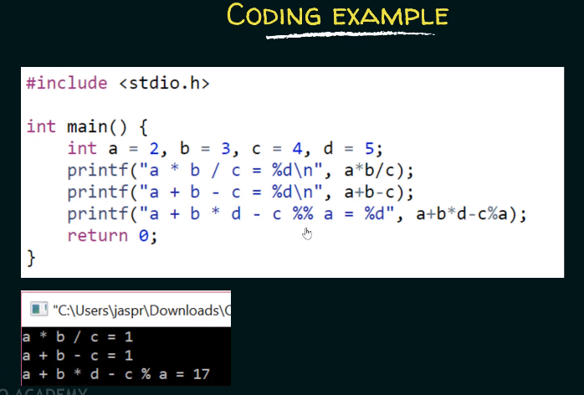

1. Look at the 3rd one and tell why the

**Increment and decrement Operators:**

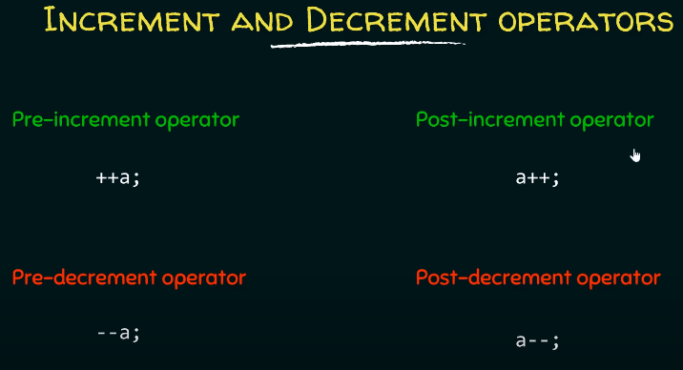

1. **Pre-increment (++i)** − Before assigning the value to the variable, the value is incremented by one.
2. **Post-increment (i++)** − After assigning the value to the variable, the value is incremented.

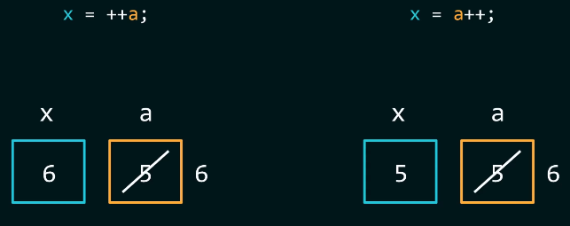

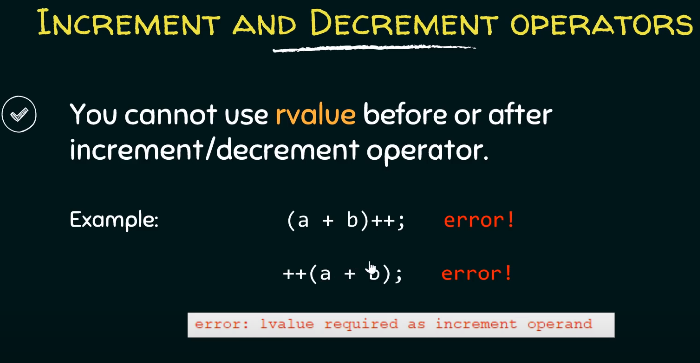

1. Lvalue: should be a variable that has an identifiable location in the memory.
2. Can’t be anything
3. Rvalue or right values are usually a expression or function that can return some value.

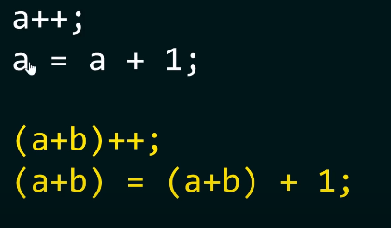

**Questions:**

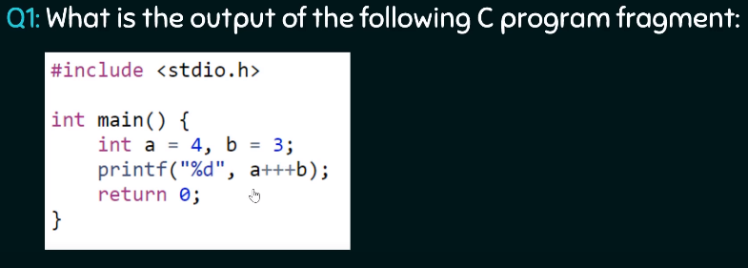

1. Lexem analyzer is analyzing lexemes from left to right.
2. Compiler will analyze valid lexemes and then assign them tokens

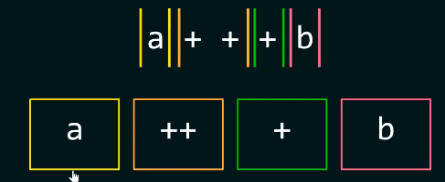

1. Post increment operator in terms of a equation : analyze the equation and then increment “a”.

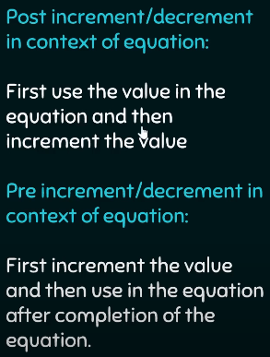

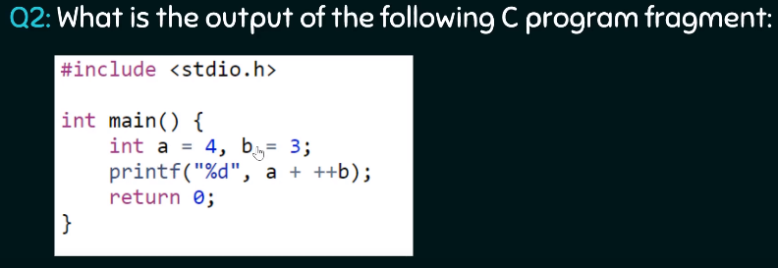

Answer: 8

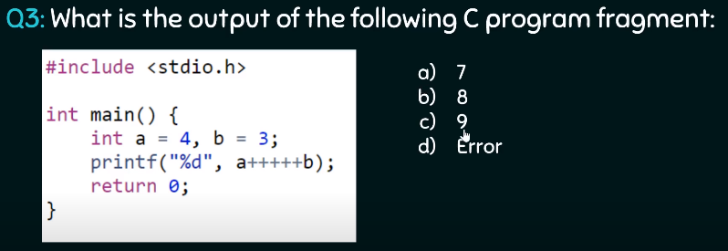

Answer: **Very important question.** Remember Lvalue concept. A++ = (a = a+1)++. **WRONG**

**Relational Operators:**

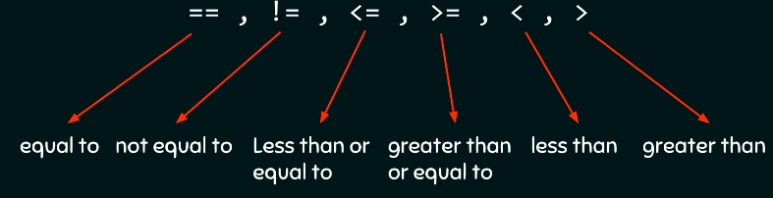

**Logical Operators:**

**Why logical operators:** Idea is to **optimize the code**. Maybe you are executing a lot of code and you want to decrease it. Then all you got to do is optimize by some sort of logical operation.

1. **And &&:** You are looking for conditions to be true by checking if **both operands** are **existing** or not. Any number that exists means it’s true.

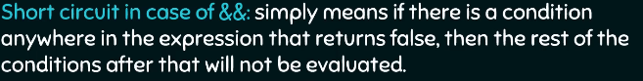

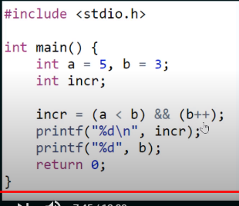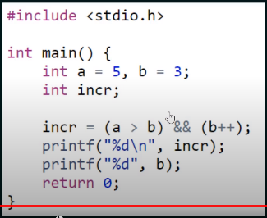

1. **OR ||:** You are looking for conditions to be true by checking if **anyone operands** is **existing** or not. Any number that exists means it’s true.

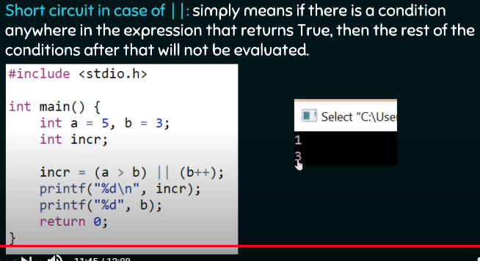

1. Look at the diagram below to understand short circuit for both && and ||

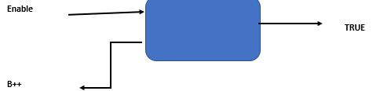

1. **In case of &&** if **Enable** is **high** **then B++ will BE looked** at to produce true. If enable is low, then FLASE is the output.
2. **In case of ||** if **Enable** is **high** **then B++ will NOT be evaluated** since, no need in case of OR. One high will produce TRUE.

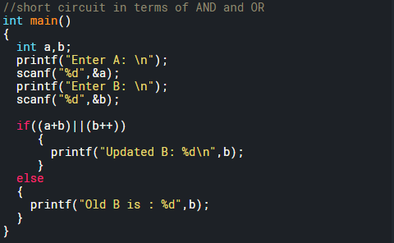

**Bitwise Operators:**

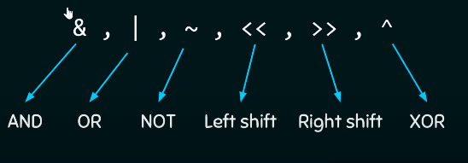

**Bitwise AND:**

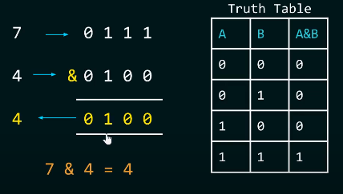

**Bitwise OR:**

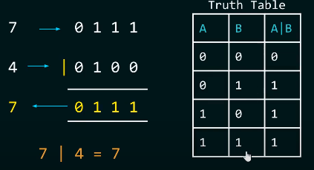

**Bitwise NOT:**

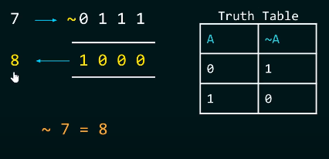

**Bitwise XOR:**

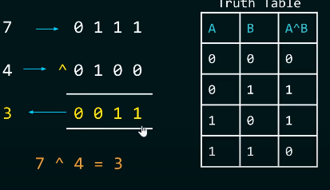

**Difference between Bitwise and Logical:**

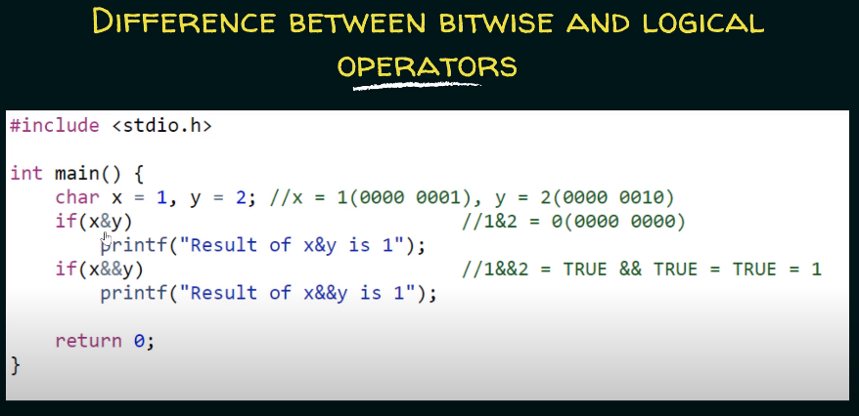

**Left shift operator:**

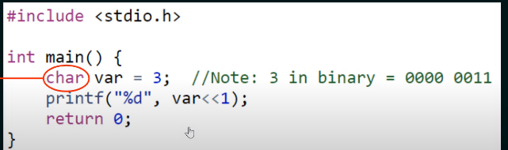

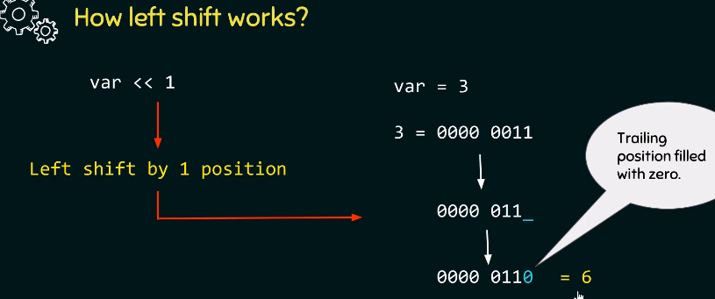

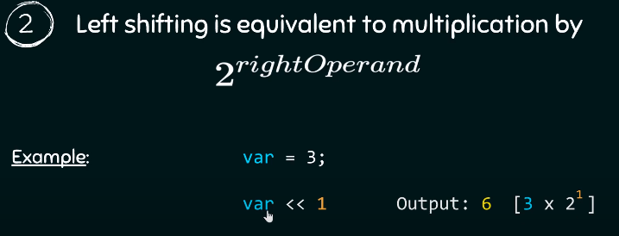

**Right shift operator:**

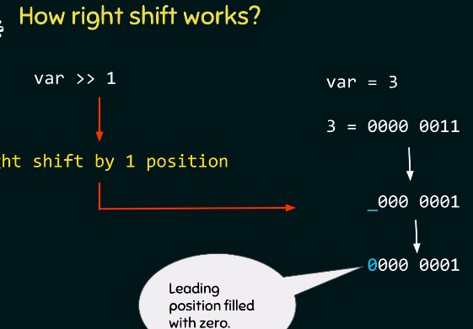

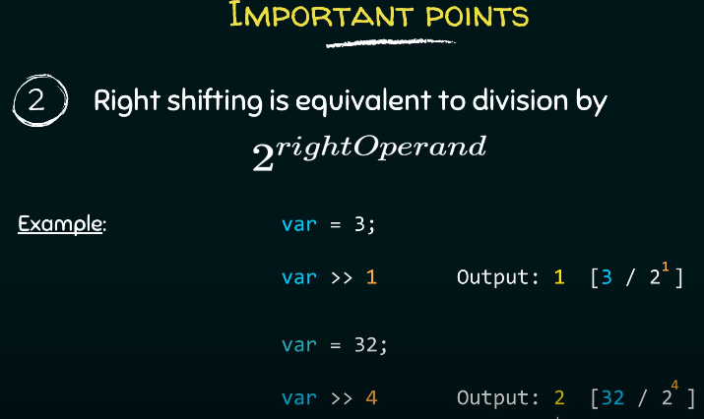

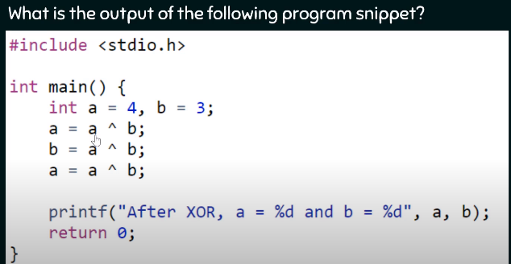

**Questions on Bit-wise operators:**

**Question 1:** Check if a given number is a power of 2.

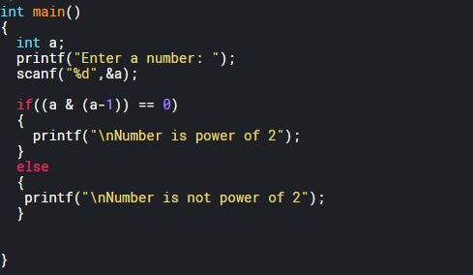

**Question 2:** Check what power of 2 is the number?

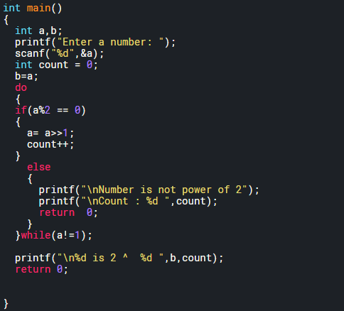

**Question 3:** Count the number of ones in the decimal.

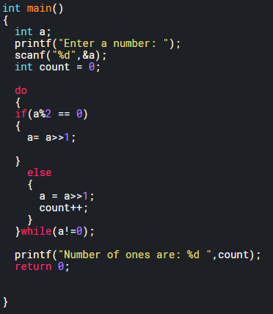

**Question 4:** Check if the i-th bit is set.

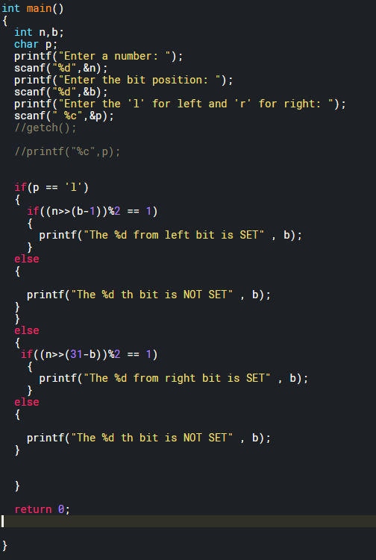

**Assignment Operators:** used to assign value to a variable.

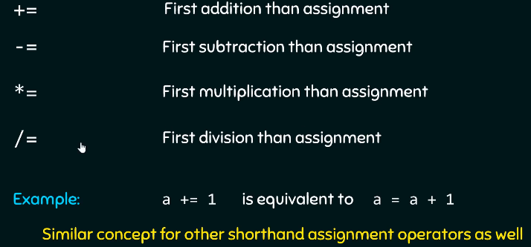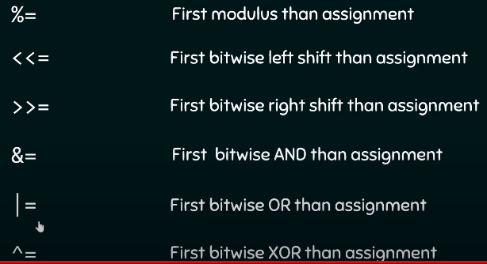

**Conditional Operators:** used to assign value to a variable.

* ? :

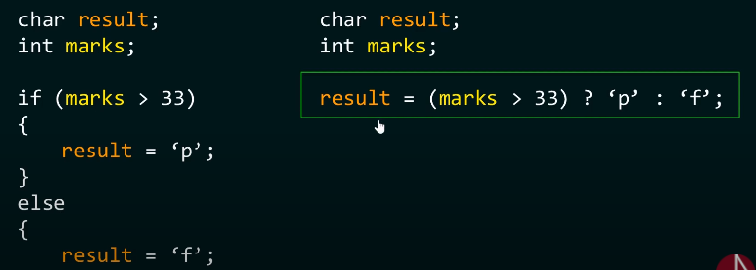

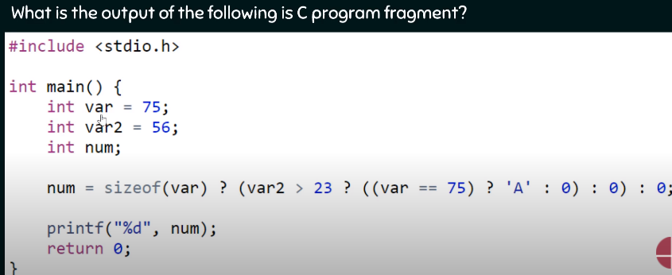

Answer: 65

**Comma Operators:** used to assign value to a variable.

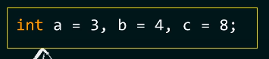 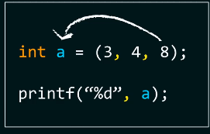

1. Comma operator will evaluate all the values but assign the right most one.
2. Below it will print HELLO and then assign VAR = 5 and later print it on screen.

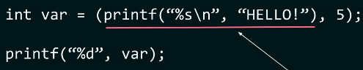

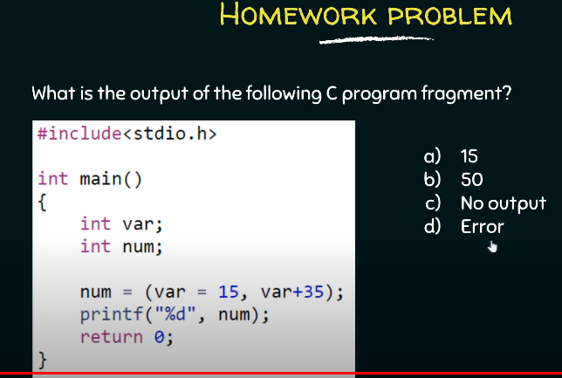Answer: **Very Important**: 50

**Precedence and Associativity of Operators:**

1. Higher precedence operator will be given priority.

**Associativity:** Associativity comes in the picture when precedence of the operators is same.

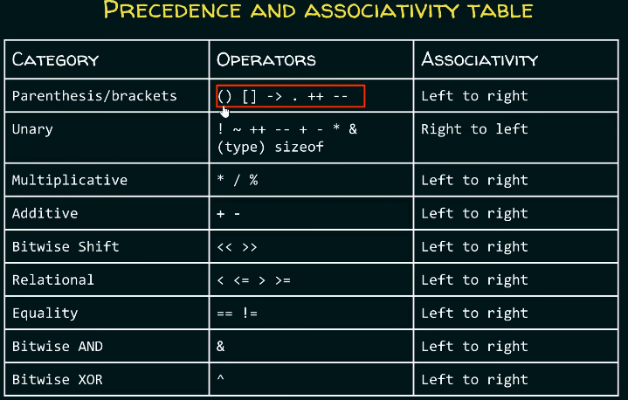

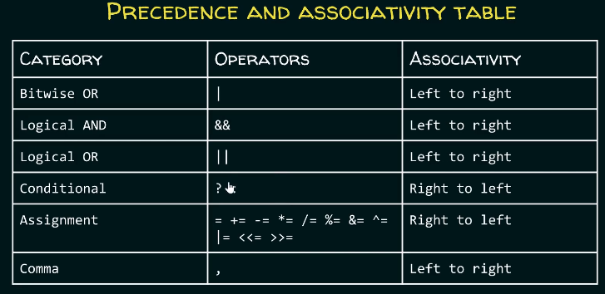

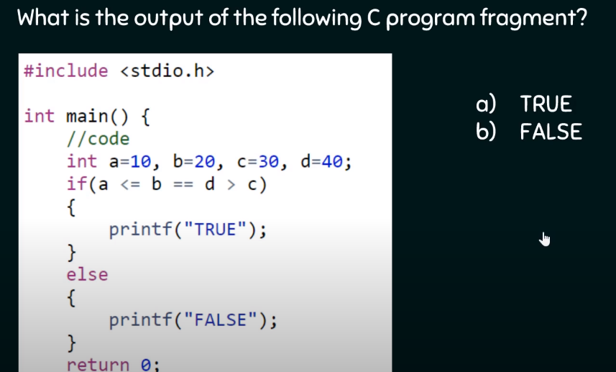

**Ans: TRUE**

**Questions:**

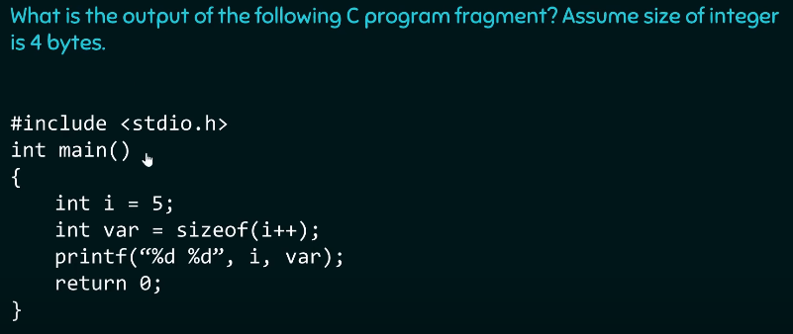

Answer: is 54 not 64. Because according to C99 standard(not C11), sizeof(i++) will give size of variable type and will only solve the expression when it’s a variable array type.

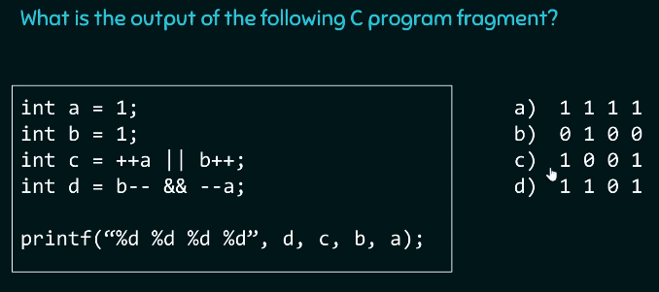

Answer: **Very Important,** work again

**Rapid Fire:**

Go back to Video 37 and do the quiz.

**Conditionals:**

**If else:**

**Switch:** Good replacement to long if else constructs

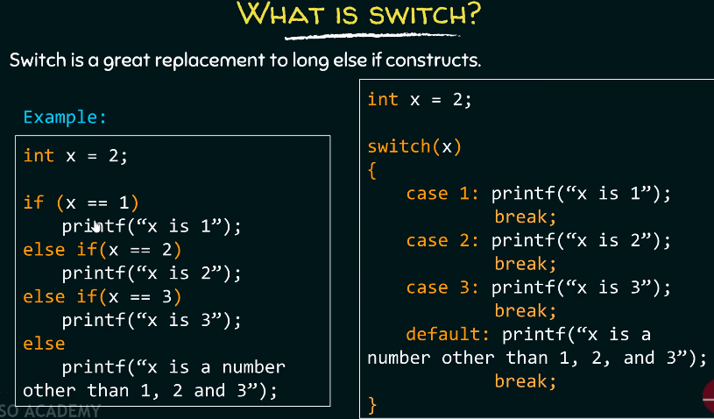

1. Why put break? If you don’t put break, then substituent functions will be evaluated **once the condition is satisfied** until we reach the **break**.
2. Conditions of switch: You aren’t allowed to duplicate cases.

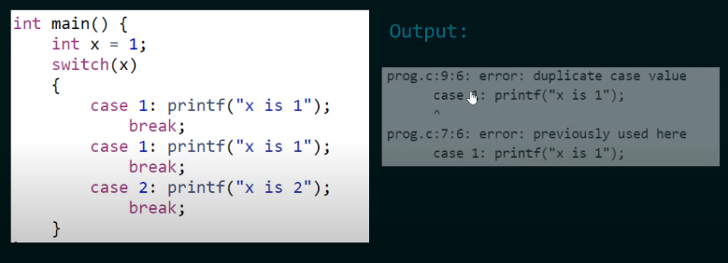

1. Only those expressions are allowed those are integral **constant values** in switch statement. **No floats** allowed.

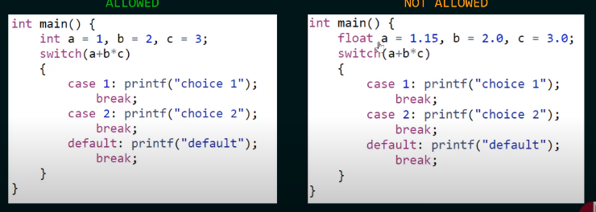

1. **Floats are not allowed in the CASE statement either**. However, **expressions** are allowed that will lead to integer value.

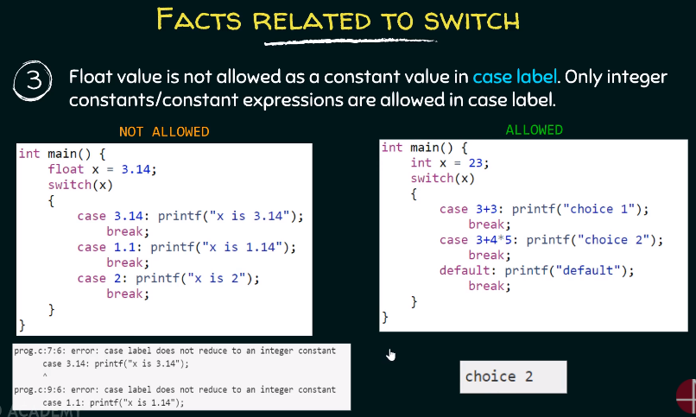

1. **Variable expressions aren’t allowed.** However, **macros** are allowed. Also, Integer.

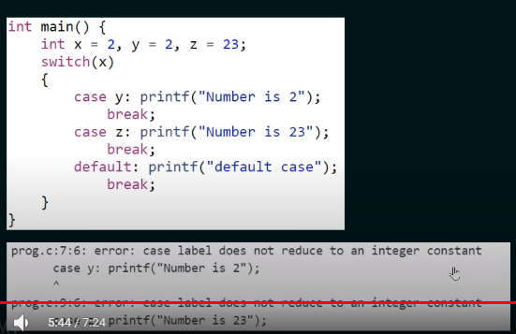 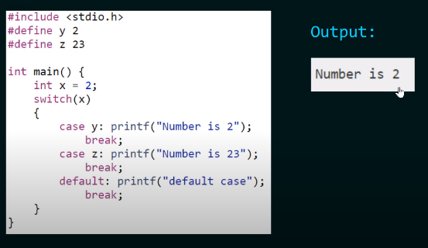

1. **Default** can be put anywhere. And will only be evaluated once all the cases are evaluated.

**For while loop:**

**While loop:**

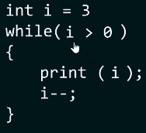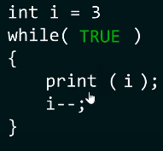

**For loop:**

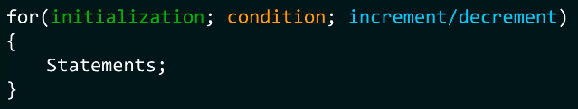

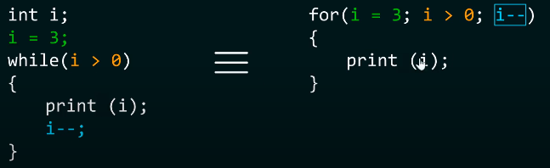

**Do while loop:** Evaluate the arguments and then check the condition. Unlike while, where you check the condition first and then evaluate argument.

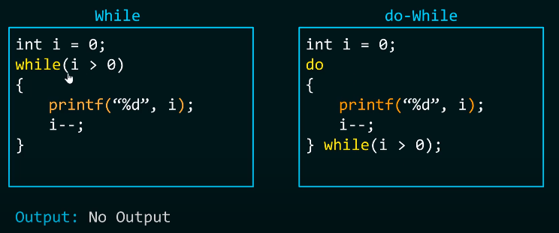

1. Write a program that allows user to enter a value, until he or she enters zero. Using while and do while genius.

**Break and continue:**

**Difference between Break and Continue: Break** the loop and **Skip** the loop.

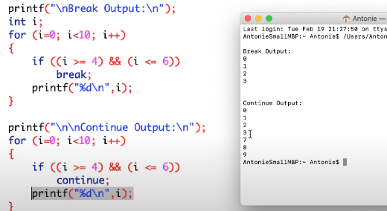

**Questions:**

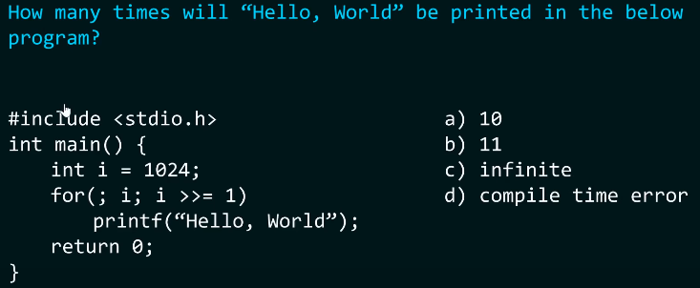

Answer: 11

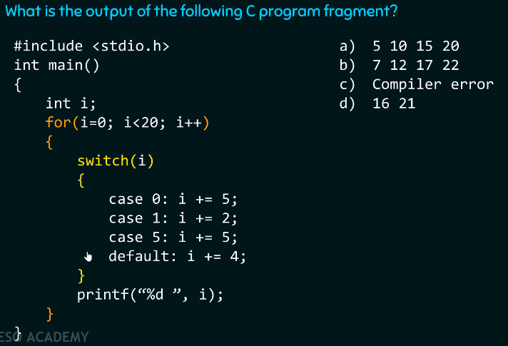

Answer: Do it on your own.

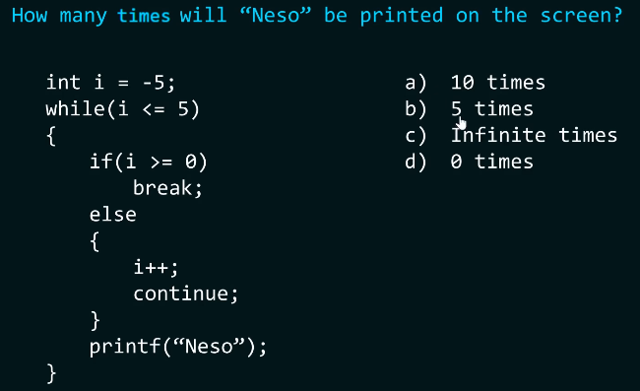

Answer: Do it on your own

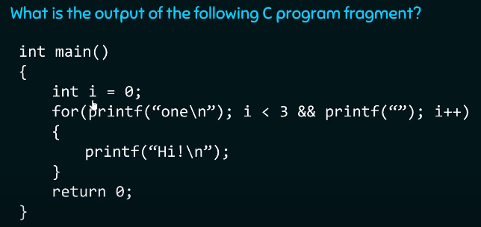

Answer: **Very Important Question.** Do it again.

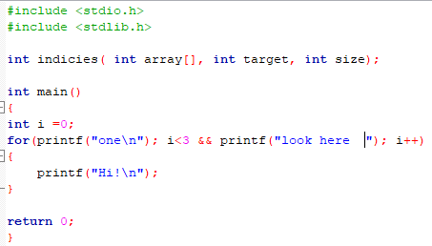 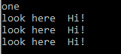

Also, look. ONE is only printed once.

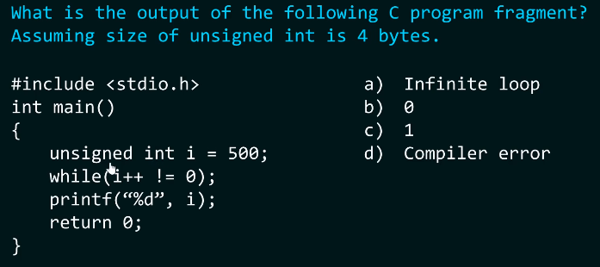

Ans: Do it again.

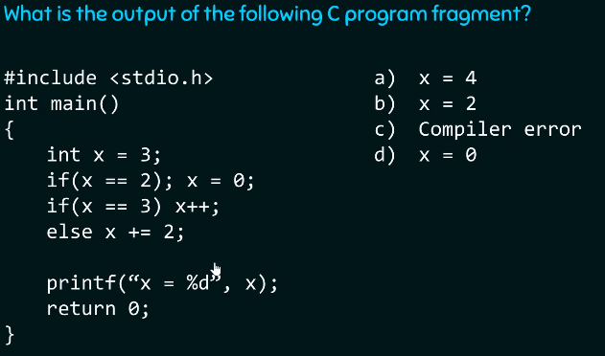

Answer: Do it again

**Pyramid of Stars Palindrome Armstrong**

**Function:**

Why functions?

* Reusability and abstraction

Function declaration as a prototype:

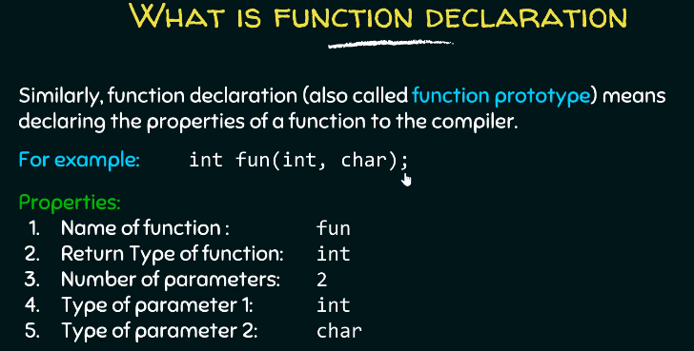

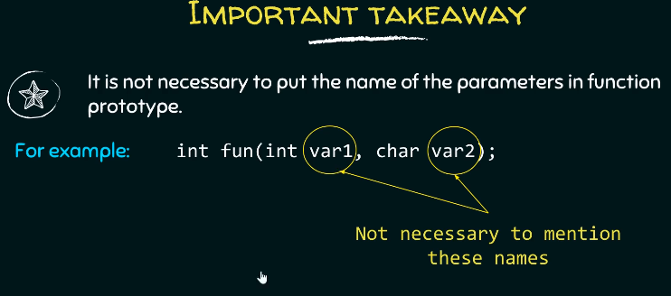

* Is it always necessary to **declare** a function before using it? No. You **do not** have to **declare**. Instead of declaration you can define the function too before the main function.
* What happens when you do not declare or define a function? Implicit declaration

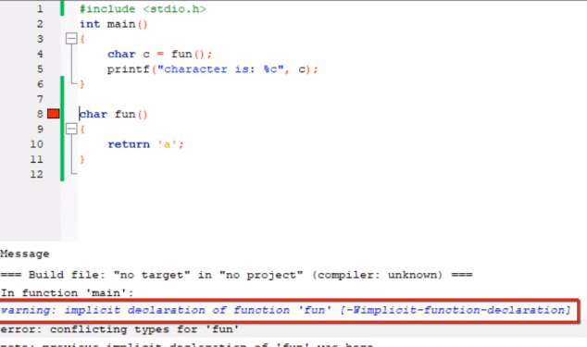

* Two errors: Conflicting types for “fun” and Implicit declaration of function.
* **Conflicting types Error:** Since the function is not declared or defined, therefore, complier assumes the return type of the function to be integer data type.
* **Implicit declaration warning**: Compiler implicitly assumed return type to be integer.
* If you declare an integer type than you can bypass function call and declaration.

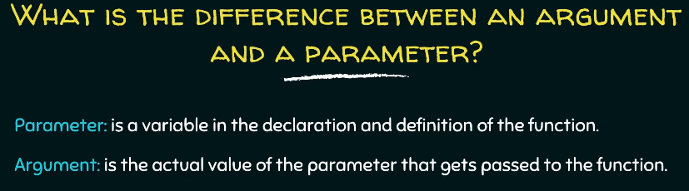

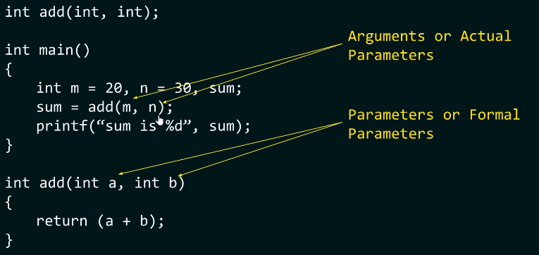

**Call by value and call by reference: With example!**

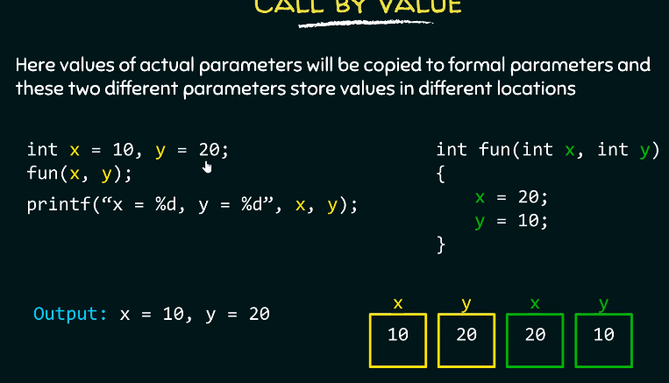

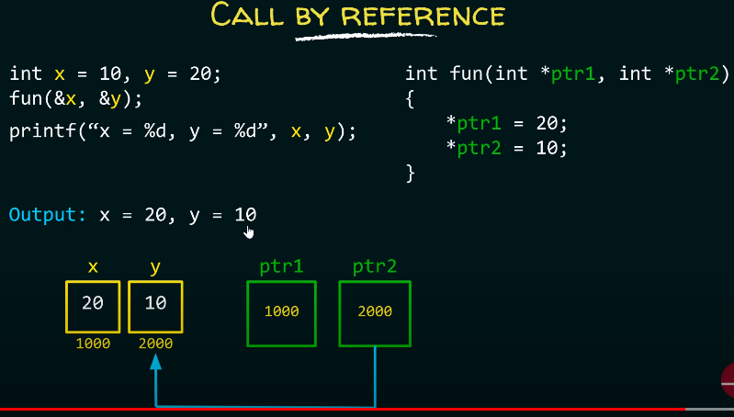

**Questions:**

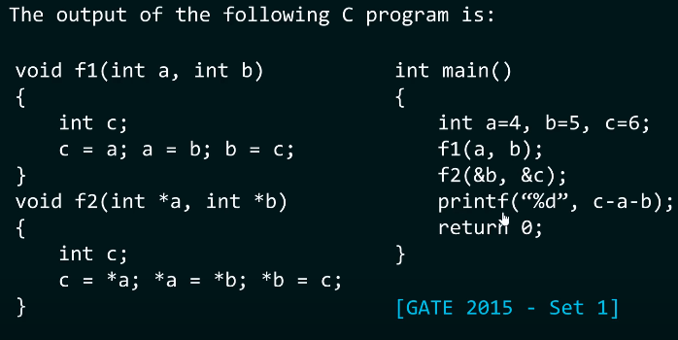

**Answer:** -5

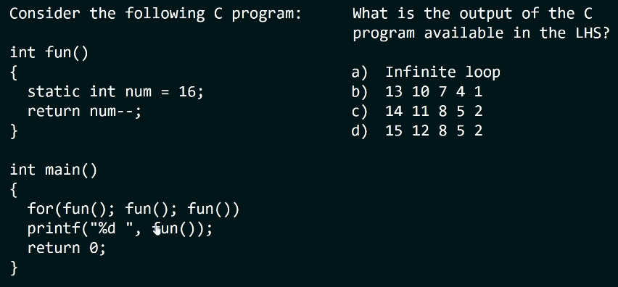

**Answer:** Very important. Do it again.

**Static Function:**

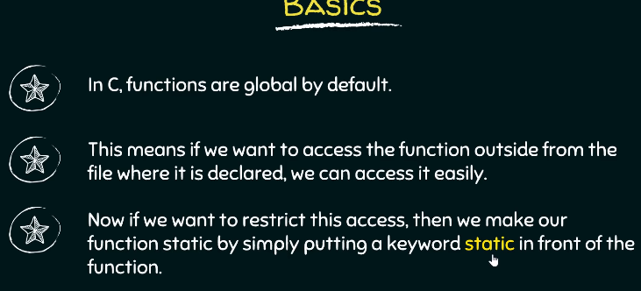

**Static scoping and dynamic scoping in C:**

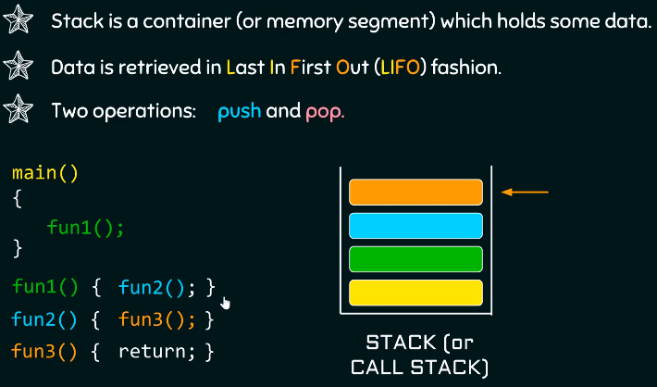 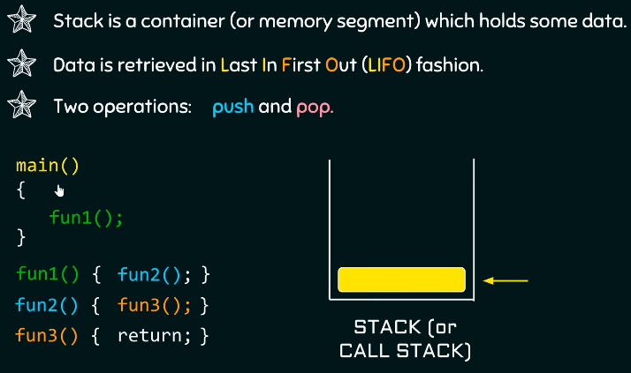

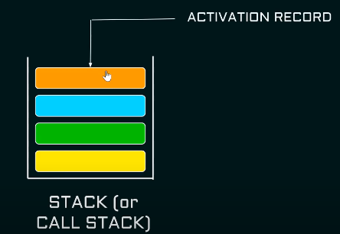 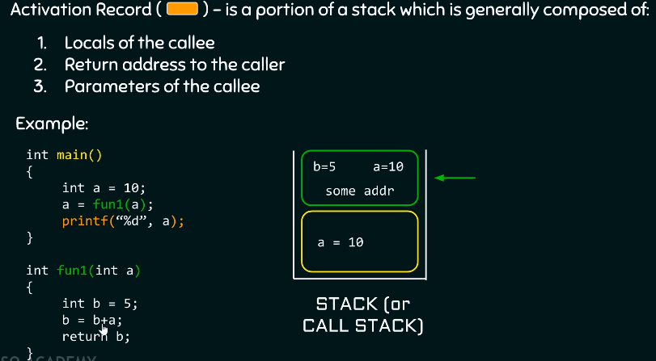

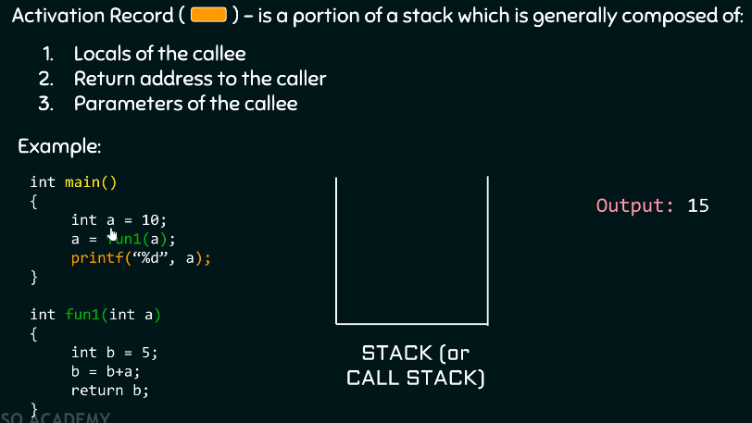

**Scoping:**

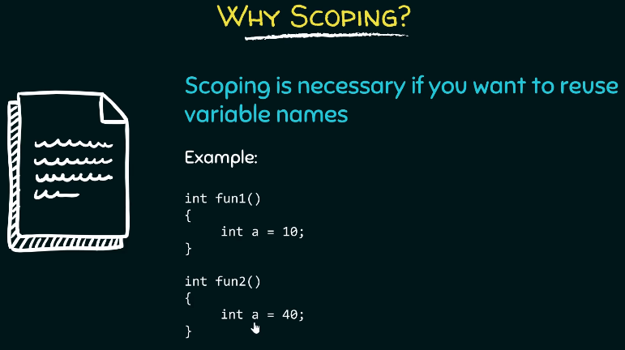

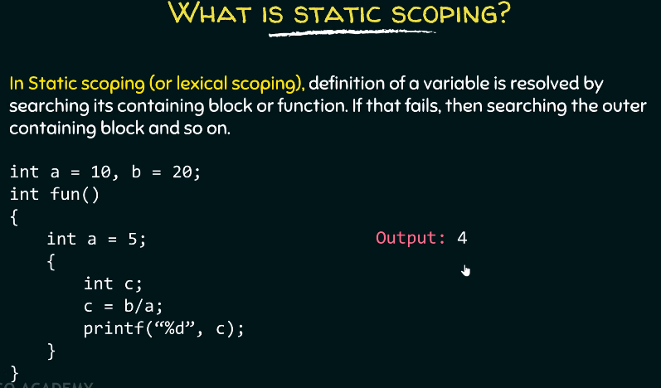 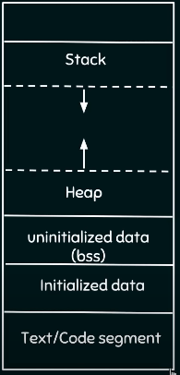

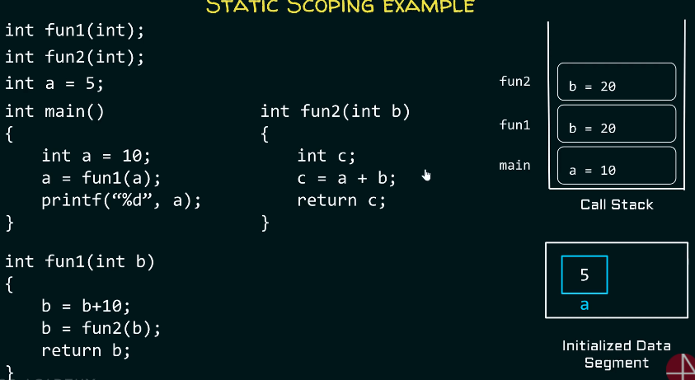

**Dynamic scoping:**

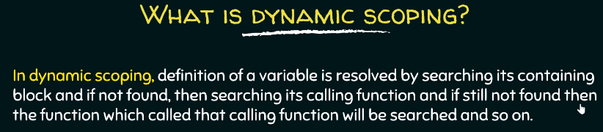

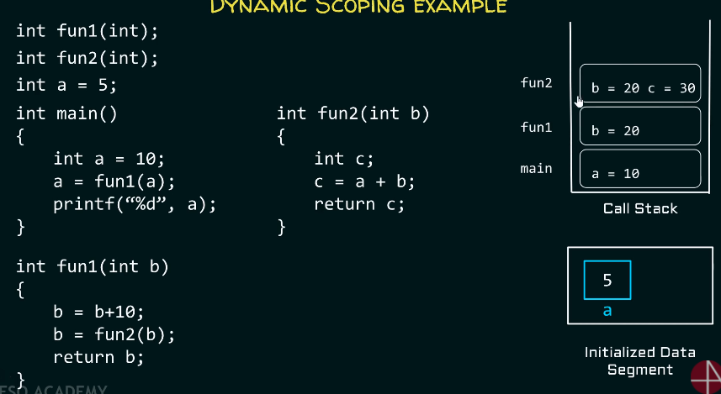

**Recursion:**

1. **Recursion: Function** calling **itself.**
2. **How to write a recursive function:**
3. **If – else** construct
4. **If (base):** return **1**; **terminate** the **recursion**.
5. **Else :** return the function itself.

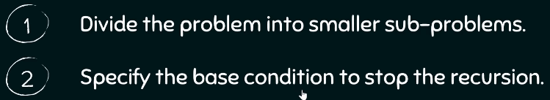

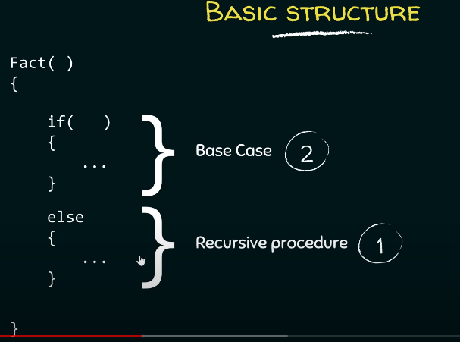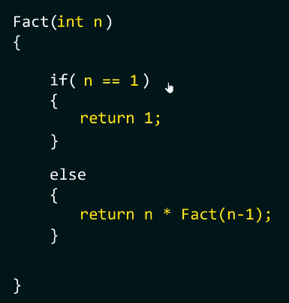

1. How to find **recursive procedure**: Look at the picture below.

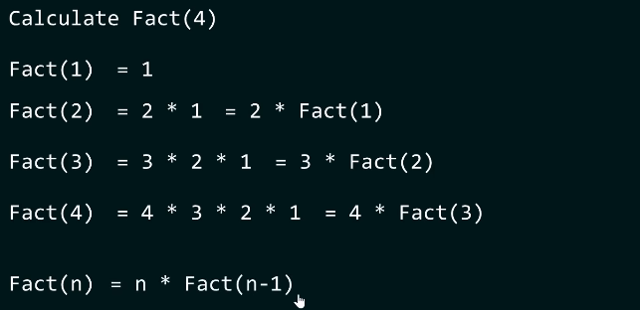

1. How to find the **base condition:** Condition which doesn’t require to call the same **function again.**

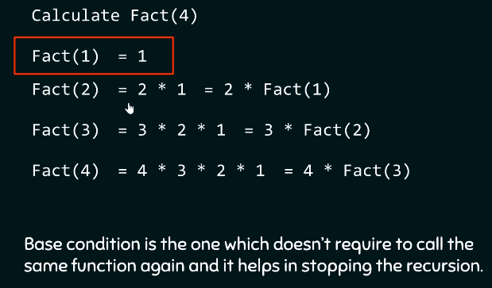

1. **Types of recursion:**

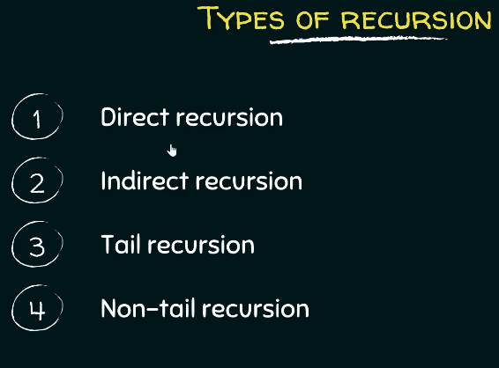

1. **Direct recursion:**

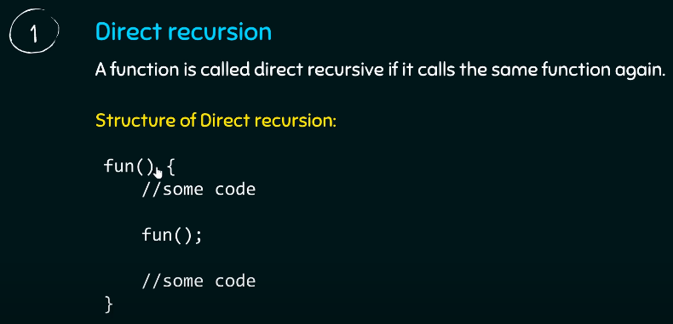

1. **Indirect recursion:**

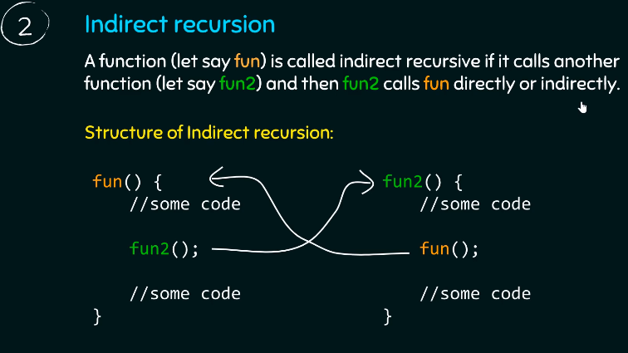

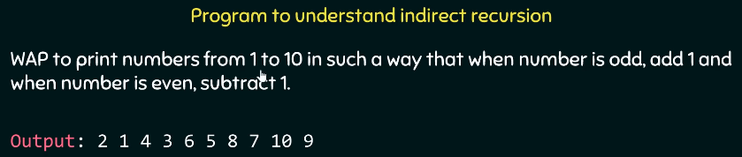

1. **Tail recursion:**

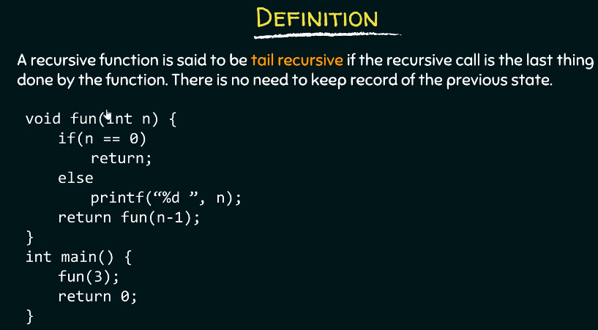

1. **Non tail recursive:**

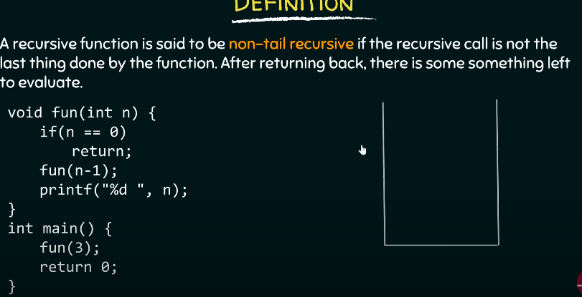

1. **Iterative program vs recursive program:**
2. **Sometimes iterative code is** too complex to write, hence recursion.
3. **Questions on recursion:**
4. Write a **recursive program** to find **sum** from **1 to n**:

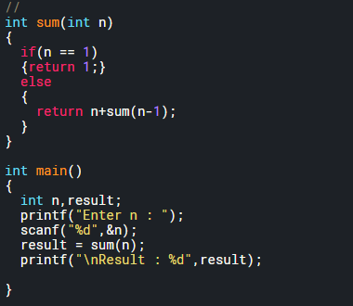

1. **Print** the **array** using **recursion:**

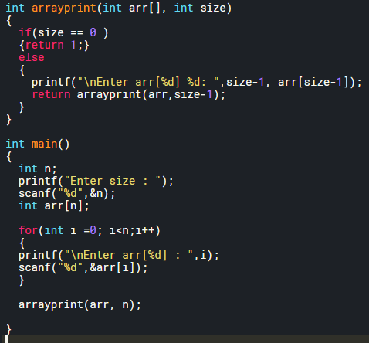

**Array 1-D:**

**What is Array:** Array is a **data structure** that contains **values of same type**.

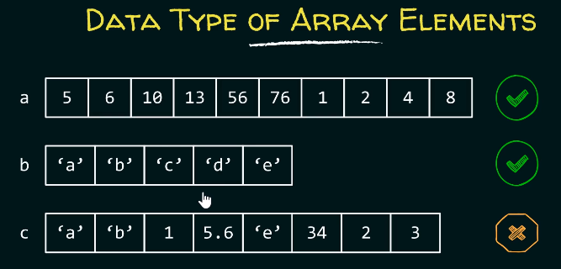

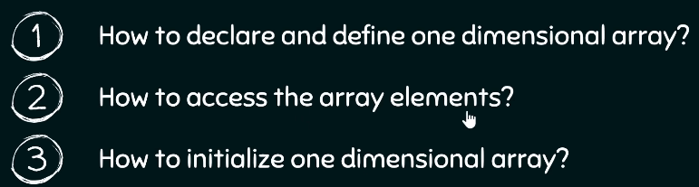

1. **Declaring an array:**

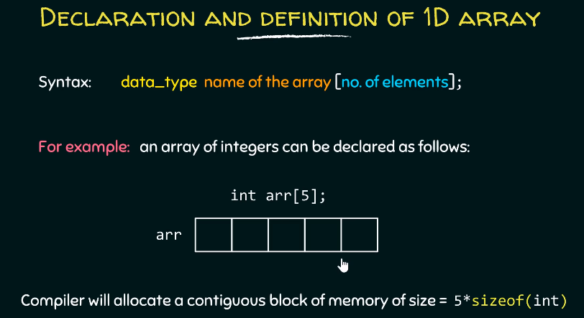

1. **Declaring size of an array:** Can be declared using a **positive** **constant value** or a **constant expression**.

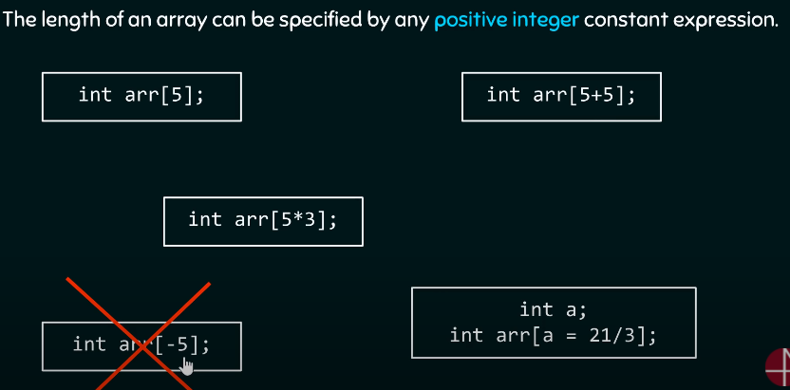

1. **How to define 1-D array:** In method 2, size is defined by the compiler since you’ve initialized the array already. You can’t create an array without specifying the size of it.

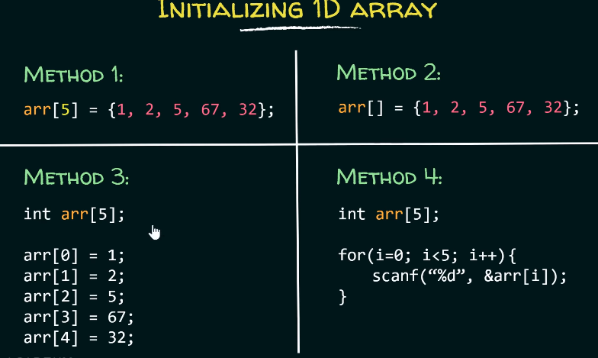

1. **Initializing the values in array:**
2. **By default**, the **value** of an **array** is initialized to **garbage**.
3. **Partial initializing** leads to reset of the elements being filled as **0s**.
4. **To initialize to all zeros,** leave the curly bracket empty.

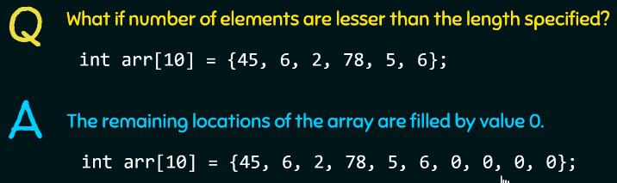

1. **What** to if we want something **like below?**

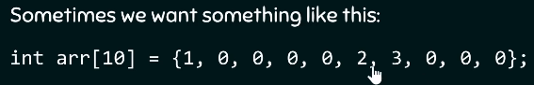

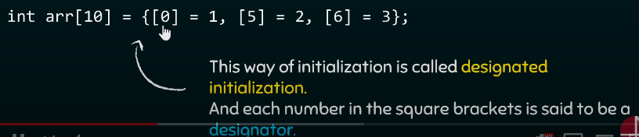

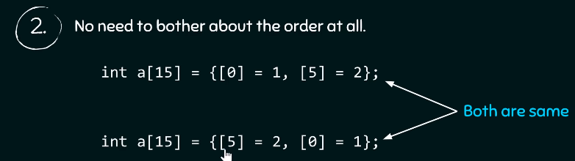

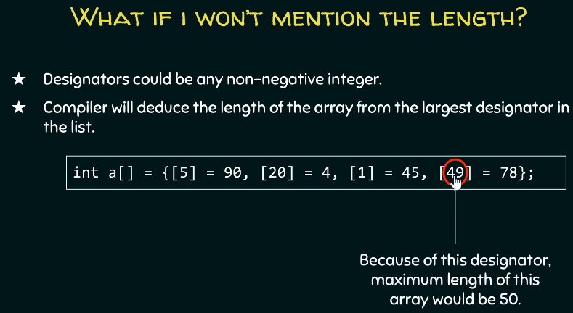

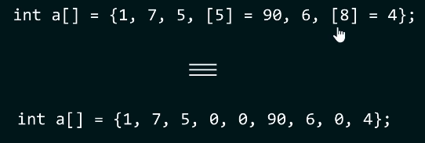

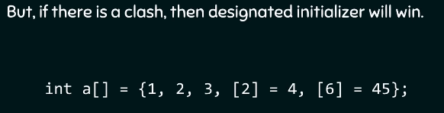

**Questions on Array 1-D:**

**Question 1:** Find the number of elements in an array.

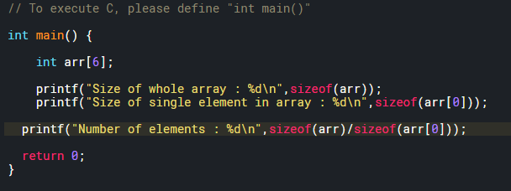

**Question 2: Traversing** through an array of limit size. Take user input from the user and fill those elements and then print them. Then change it to character array and float array.

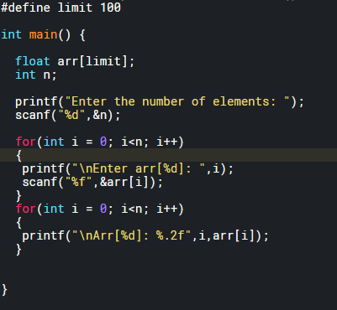

**Question 2: Insertion** in an **Array**.

1. **Rules for insertion:**

* Array[limit-1] = array[limit-2] ; limit—
* Till **position +1;**
* Insert new value at **position-1**

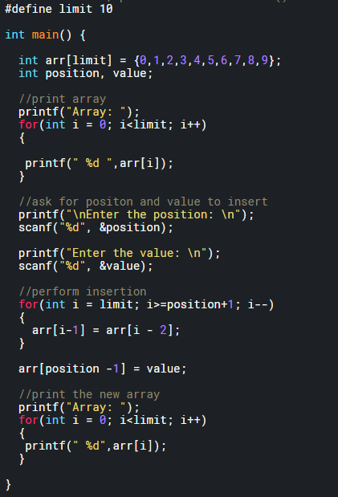

**Question 3: Deletion** in an **Array**.

1. **Rules for Deletion:**

* Array[position-1] = array[position]; position++
* Till **limit;**

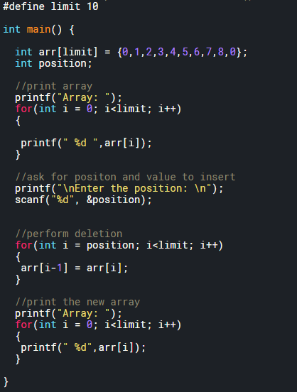

**Question 3: Reverse** the elements in an **Array**. Then reverse **first half of an array**.

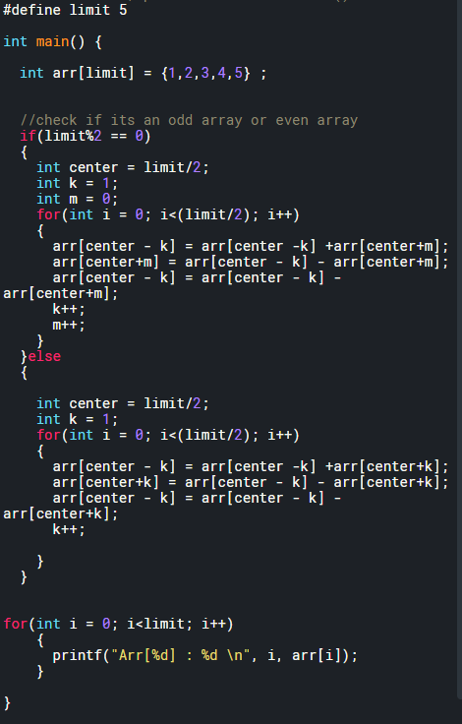

**Question 4: Convert decimal to binary** then store it in an array.

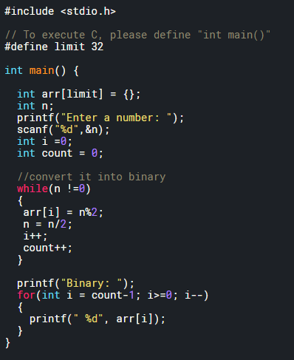

**Question 4: Print odd and even number** separately.

**Question 5: 2nd largest element in array.**

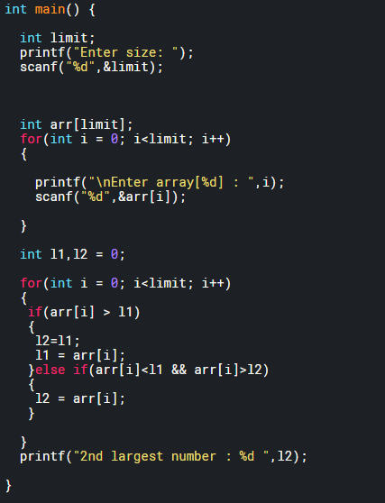

**Question 6:** How many times **each element repeats itself in the array**.

**Pointers:**

1. **What are pointers? Address**, pointers are **ADDRESS also called REFERENCE**. Don’t think of them as anything else.
2. What happens when you **pass in a pointer?** You pass the **address.**
3. What happens when you **return a pointer?** You return the **address.**
4. Remember: Referencing: **&address** and dereferencing: **\* Value.**
5. **Declaring and initializing pointers:**
6. **Declaring a pointer:** Specify which data type will it point to. Ex: char*ptr will point to character and int*ptr will point to an integer.
7. **Defining a pointer:** Specify which address will it point to. **int* ptr = &x**. Look, we have assigned the **address of x** to ptr.
8. **Value of operator or dereferencing operator:**
9. When you print the pointer, you print the address of the variable the pointer points to.
10. To get the value we have to de-reference a pointer using * operation.

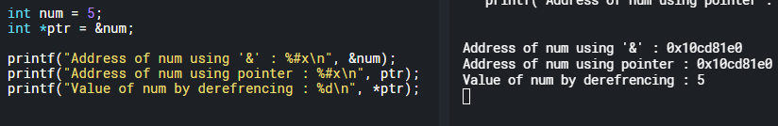

1. **Caution:** Do **not dereference** a **pointer** that is **not** been **initialized** i.e., **a wild pointer.**
2. What will happen if we **dereference a wild pointer**? **Segmentation fault.** Wild pointer may point to a memory location, but we don’t have a legal right to access that memory location. Hence segmentation fault.
3. What is **segmentation fault: Program** trying to **illegally read or write** to a **memory location.**
4. **Pointer assignment:**
5. **Address assignment:** When you assign one pointer to another then you are assigning the content of one pointer to another i.e., the address. Look at the example below to understand it better.

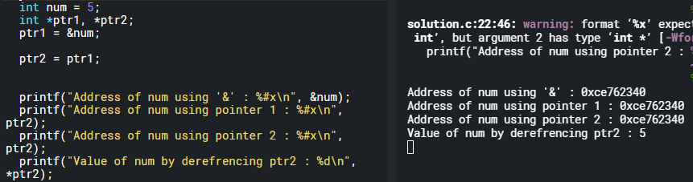

1. **We can also assign the value of one pointer:** ptr2 = *ptr1, by dereferencing it.
2. **Question:** Just by reading.

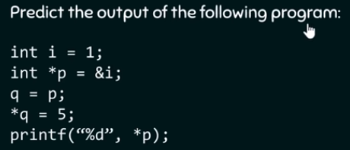

1. **Pointers and functions (Pass by value and pass by reference):** Write a function that uses pointers to find the min and max value of the array and returns the value.
2. **Pass by value vs pass by reference:** Why pass by reference? You can’t return two values in C from a function.

* **Pass by value:** You pass in the value of the variables and do computation and come back. **You do not change the value of the variable.**

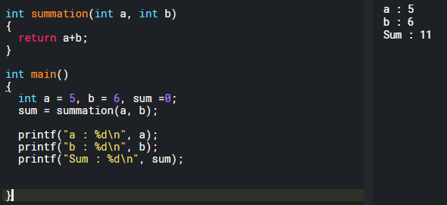

* **Pass by reference:** You pass in the address of variables. Do computation and return the sum.

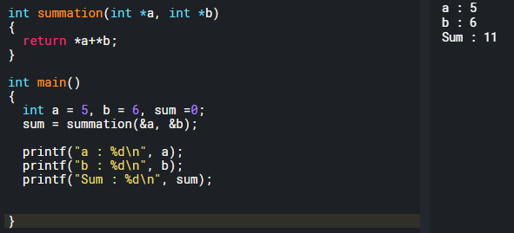

* **Difference between pass by value and pass by reference:** In pass by reference, you can actually change the content of the register.

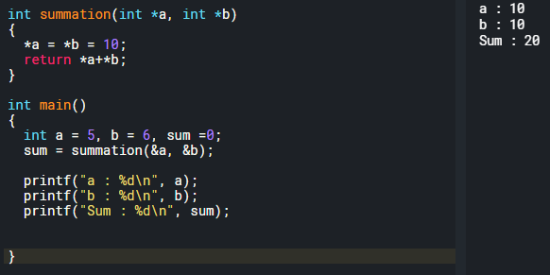

* **Why else use pass by reference?** Try returning 2 values from a function.

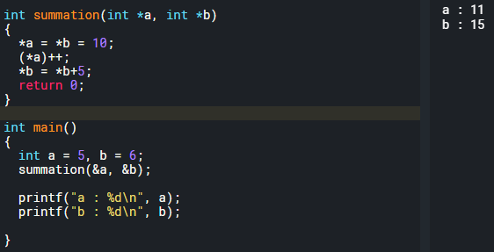

1. **Another example of changing values by passing them by refrence:**

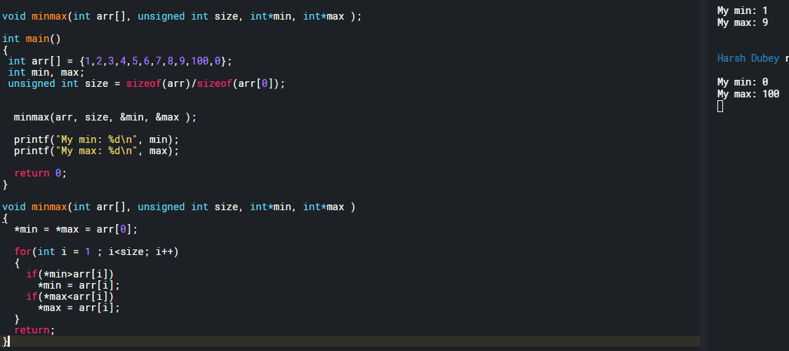

1. **Accepting and Returning pointers from function:** Return the pointer to the midpoint of an array then change the 1st byte of it for an integer.
2. **Accepting:** Accepting a pointer means accepting the address

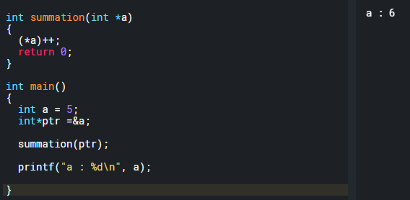

1. **Receiving a pointer:**

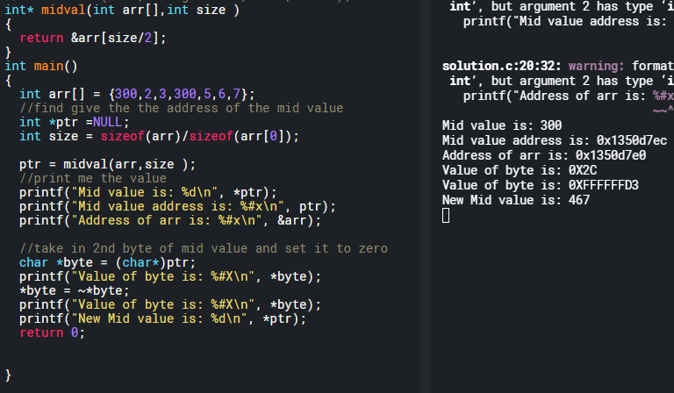

1. Redo this using **float and double precision. Print out mantissa, exponential and sign bit.**  For float: 4.25. And the figure out the **endianness of the system**.
2. **Big endian: MSByte** in the **smallest address.**
3. **Little endian: LSByte** in the **smallest address.**

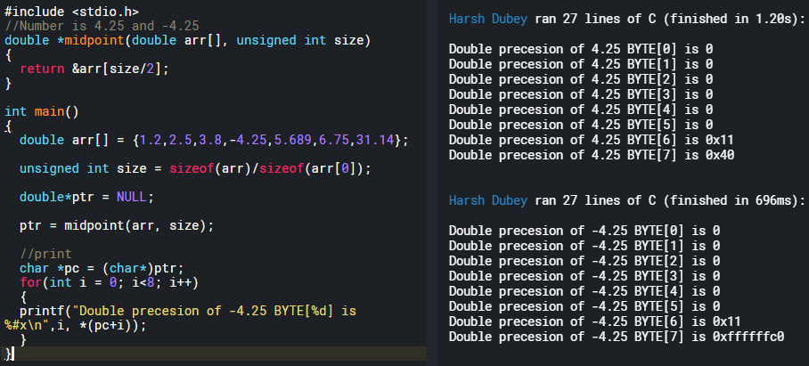

1. **Convert floating point into binary:**

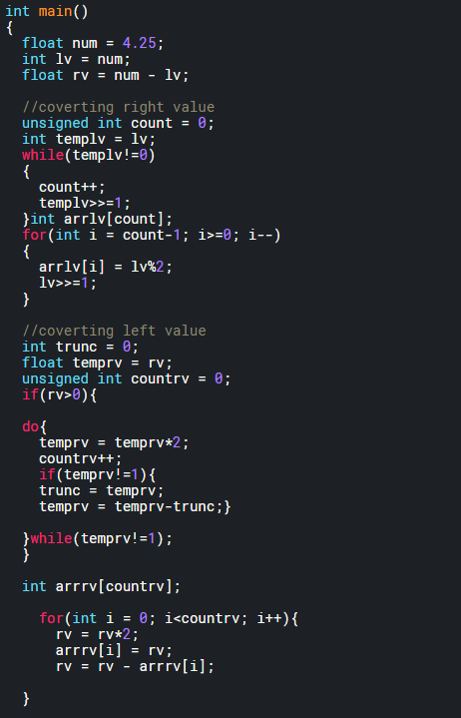

1. **Questions on pointers:**

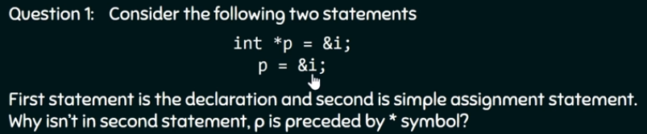

**Answer:**

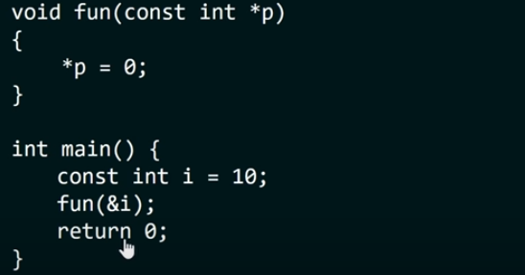

**Answer: Error.** Assignment to read only location.

1. **Pointer arithmetic:**
2. **Adding integers to pointer:**

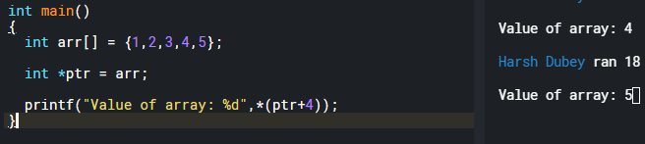

1. **Post increment and pre-increment:**

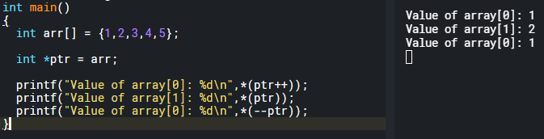

1. **Comparing the pointers:** Only possible if both pointers point to the same array? No.
2. **Stack using a pointer:**
3. **Stack using pointers:** Grows up. Last element empty.

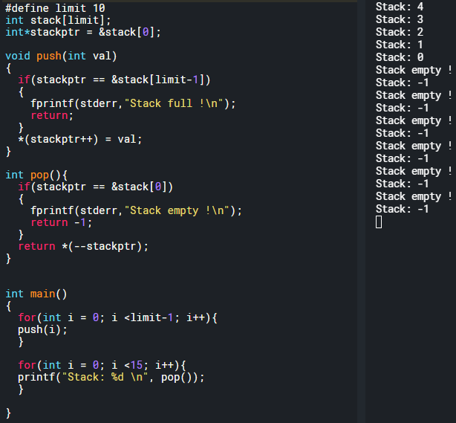

1. **Queue using pointers:** pushptr and popptr
2. Pushprt > popptr:
3. Pusptr reaches the top:
4. Pushptr == popptr : we can’t pop
5. Popptr reaches the top
6. Popptr > pushptr:

**2D and 3D array: Could be more.**

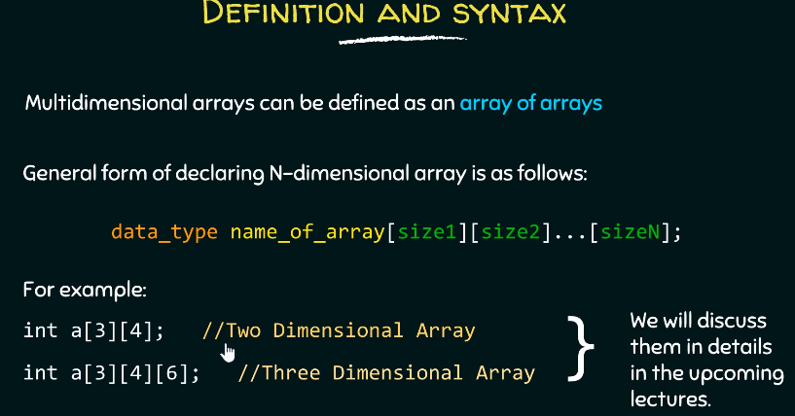

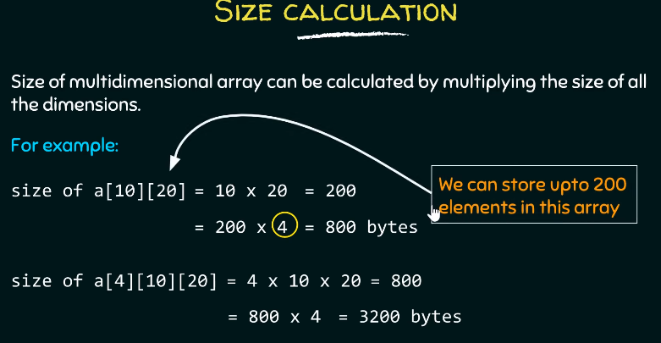

**C Interview questions:**

1. **Null pointer:** Pointer that points to nothing. Why we need it? So that there is no garbage value assigned to our pointers.
2. **Void pointer and limitations of void pointer:** It can point to any data type. Ex, can hold address of integer, float, char. But can’t be used without doing type casting.
3. **Interrupt latency and how to reduce interrupt latency.:** Time b/w last instruction of interrupted task and first instruction of ISR or interrupt handler.
4. **What is interrupt dispatch latency?**
5. **Volatile keyword.**
6. **Can we make a pointer volatile?**
7. **Printf and malloc inside an ISR?**
8. **Can we use breakpoint in an ISR?** You can surely debug the code using it but no guarantee for real time performances.
9. **Nested interrupt? Interrupt inside another interrupt. High in low.**
10. **What is embedded C?**
11. **What are real time systems and RTOS?** Logical correctness of the system within the time constraints. OS that can support real time operations.
12. **Types of RTOS: Hard** (Air bags), **Firm** (Quality decreases) **and soft** (can miss the deadline).
13. **Features of RTOS:**
14. **RTOS overhead time:**
15. **Inline function: C++ not in C.**
16. **Static variable**: Block and Automatic variable
17. **Why can’t we debug the static function**? They become inline since the compiler knows more about them and hence becomes really hard to debug.
18. **Priority inversion**.
19. **IPC mechanism**: Pipes, FIFO, Message-queue, shared memory, common files, socket
20. **FIFO vs PIPE**:
21. Inter process communication vs Communication between the processes that have a same ancestor.
22. Can independently read and write, read and write happen at the same time.
23. Can give u control and ownership, no control or ownership.
24. Half duplex vs simplex.
25. Can exists after process dies and can’t exist after process dies.
26. ## operator or Token pasting: takes two arguments and concatenate two arguments together.
27. **Forward referencing wrt to pointers:** Memory for pointer is created but it won’t know which data type it will point to.
28. **How to code infinite loop:** while (1) and for (;;)
29. **What is static linking:** Linker will link all the libraries and link create an executable image. This can port across system where the libraries might not be present.
30. **What is Dynamic linking:** You just have the name of the libraries and they are linked when the execution starts.
31. **Wild pointer:** Pointer which is not initialized.
32. **Dandling pointer:** Pointing to object that doesn’t exists.
33. **Near pointer:** Bit address up to 16 bits only.
34. **Far pointer: 32 bits** or typically a pointer that can access information outside a given memory segment.
35. **Register storage class:**
36. **Malloc() and calloc():** Malloc() is used to allocate one block of memory and calloc is used to allocate multiple blocks of memory.
37. **When to use realloc() and any specific condition available for the same:** When you want to reallocate the memory but keep the data intact.
38. **Why segmentation fault happens:** Memory violations: Stack overflow, try to write to read-only memory, improper use of scanf.
39. **Segmentation fault vs core dump:** Core dump is a file that is written when a program crashes or a segmentation fault happens. So that the programmer.

**Dynamic memory allocation:**

**Malloc and realloc:** Malloc allocates a **chunk of memory** and **returns void pointer** to the starting address of memory location. Why void pointer? Bc it doesn’t know what it’s pointing to.

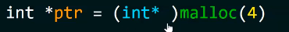 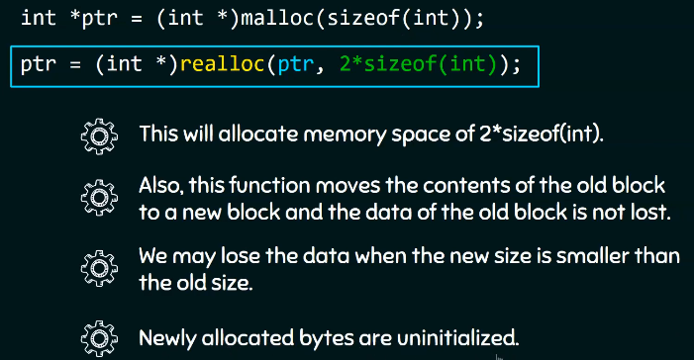

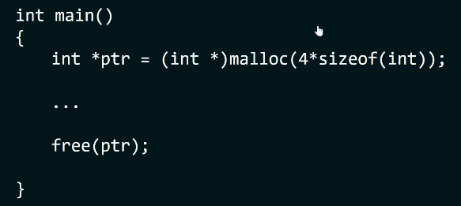

**Oscope basics:**

1. **Edge Trigger:** Trigger when to collect the data. You can bring the trigger knob down to stop the running waveform or you can trigger on rising or falling edge.
2. **Pulse trigger:** Trigger if the pulse is less than, equal to , or greater than the entered pulse width.
3. **Mode:** Auto and normal.
4. **Auto mode:** The oscope will trigger even though it’s not in triggering setting. (knob is not on the wave form)
5. **Normal mode:** Last captured waveform.

**Logic analyzer:**

1. Hate logic analyzer: Doesn’t show what’s actually happening.
2. Timing analysis vs State analysis.
3. Timing analysis: Have to provide internal clock. Asynchronous mode.
4. State analysis: Have to provide external clock. Synchronous mode.
5. Sampling memory: sequential sampling vs compression sampling.
6. 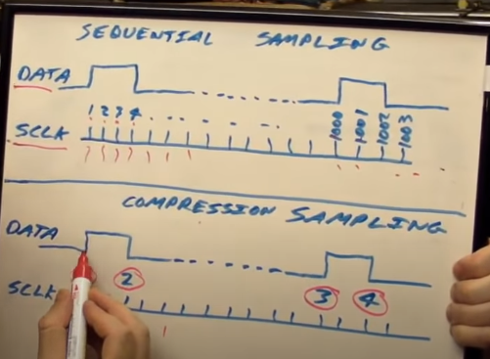

**Take home challenge:**

1. **Readme file:**
2. **Contributors:**
3. **Brief description and Introduction:**
4. **Planning:** Whatever planning went before the actual code.
5. **Technologies used for the code:**
6. How to do running and debugging.
7. Future improvement. What if there was more time?
8. **Unit test and integration test:**